Anglo-Saxon and Viking Timeline
LI: read and write numbers written using Roman numerals.
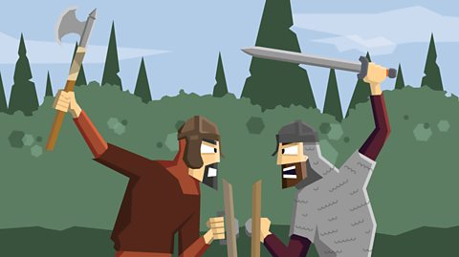
DATE | ROMAN NUMERALS | EVENT
 | DC | The Saxons gradually take over the land and split it into different kingdoms including Northumbria, Mercia, East Anglia and Wessex.
793 AD |  | The Vikings attacked the Monastery of Lindisfarne (Northumbria) having left from their settlements in Norway.
 | DCCCLXVI | The Vikings captured the city of York.
 | DCCCLXXVIII | The Vikings settle permanently in Britain, overrunning Wessex and forcing King Alfred into hiding.
871 AD |  | Alfred the Great becomes the king of Wessex and drove the invading Vikings from the south. Despite this, Vikings remain in control of the north and east.
886 AD |  | Finally, King Alfred agrees to a treaty with the Vikings which gave Alfred the west and the Vikings the east – this later became known as ‘Danelaw’
 | CM | The Vikings establish rule over the northern most part of Britain (now known as Scotland)
 | CMXXIV | Alfred the Great’s grandson (Athelstan) becomes the king of Wessex. In 927, he conquers the last Viking kingdom remaining (York) and becomes the first King of England.
937AD |  | Athelstan’s rule is resented by the Welsh, Scots, Irish and Vikings who ally to destroy his rule. Athelstan defeats the rebels.
 | CMXXXIX | Athelstan dies and the Vikings (led by Olaf Guthfrithsson) invade England reclaiming the North.
954 AD |  | The last Viking King of Jorvik (York), Eric Bloodaxe, is forced out of the city.
DATE | ROMAN NUMERALS | EVENT
 | MXIII | King Sven of Denmark and his son, Cnut, sail up the rivers Humber and Trent to claim the throne in Danelaw. As a result, the Saxon King (Etherlred) flees abroad. A year later, Cnut becomes the King of the Danes and the King of England.
1042 AD |  | Edward II (better known as ‘Edward the Confessor’)is invited to return from Normandy to become the King of England.
 | MLXVI | Edward II dies and Harold, the Earl of Wessex, is crowned king. Despite this, William (Duke of Normandy) and Harold Hardrada (King of Norway) threaten to lay claim to the thrown of England. King Harold (the final Anglo-Saxon king) is defeated during the Battle of Normandy by William the Conqueror. This is the start of Norman Britain.

