The Avengers Appraisal – Statistical Graphs
The Avengers are having their annual performance management meeting with Nick Fury in which their superhero stats are presented to them and they have to answer some questions about them.
Can you help our heroes answer those questions?
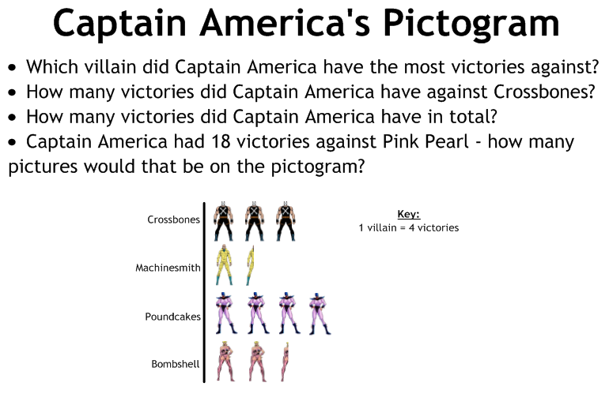
Capt. A - Answers:
- Poundcakes
- 12
- 44
- 4½
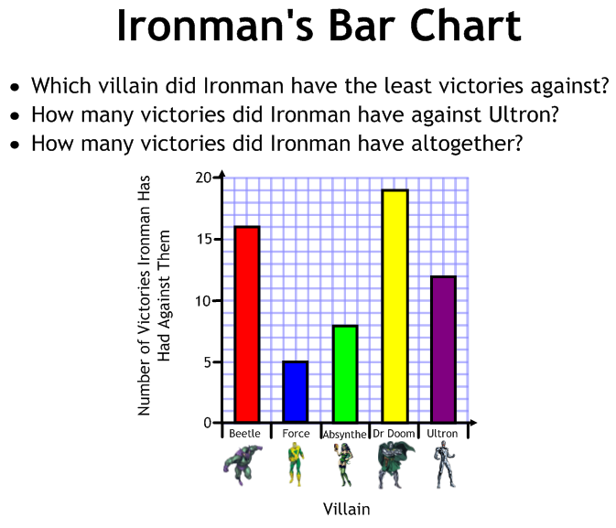
Ironman - Answers:
- Force
- 12
- 60
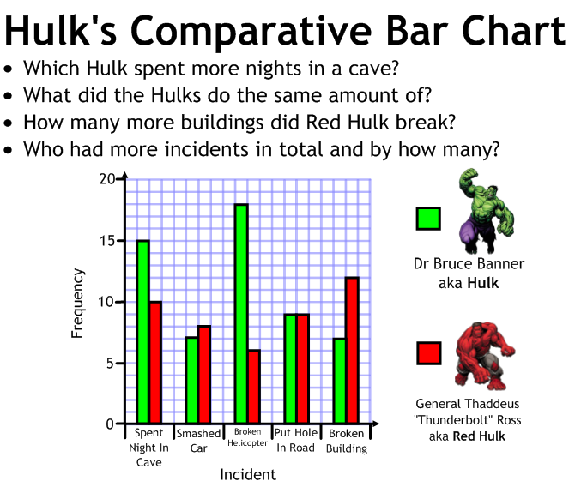
Hulk - Answers:
- Bruce Banner
- Put Holes In Roads
- 5
- Bruce by 16

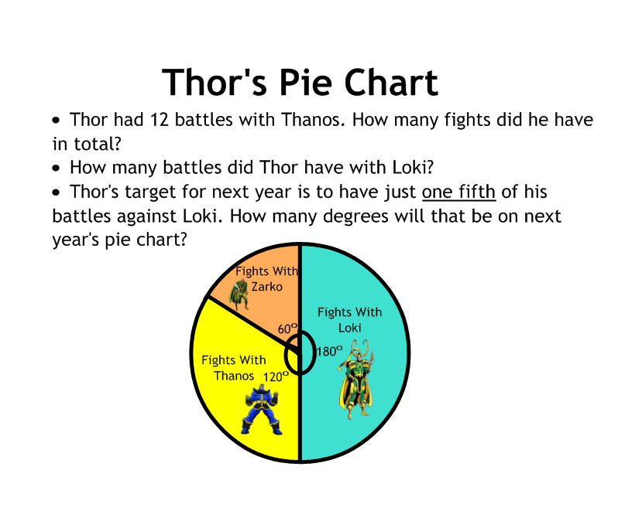
Thors - Answers:
- 36
- 18
- 72⁰

