Baking Bad – Season 5 – Data Handling
William “Billy” Black wants to see if he’s on course to hit his targets regarding the money he’s made to provide for his family once he’s gone off with the aliens.
He has a computer programme that has provided him with some data.
Can you help him interpret that data?
Pictogram – Bread Sales
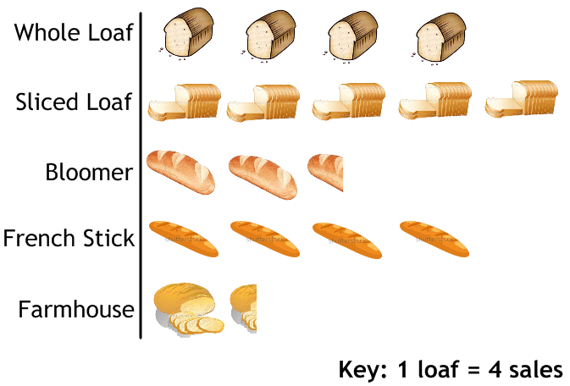
- Which is the most popular loaf?
- How many sliced loaves has he sold?
- How many loaves has he sold in total?
Bar Graph – Cakes Sales

- Which is the most popular type of cake?
- How many flapjacks has he sold?
- How many cakes has he sold in total?

Pie Chart – Pie Sales

- Which is the most popular type of pie?
- What fraction of the total sales are made up by chicken and ham pies?
- If he’s sold 7000 chicken and ham pies, how many pies has Billy sold in total?
Bar Graph – Average Sales

The graph shows how many cakes 50 customers each bought.
Calculate the average (mean, median and mode) and range for this data.
Workings:

Frequency Polygon – Average Spend
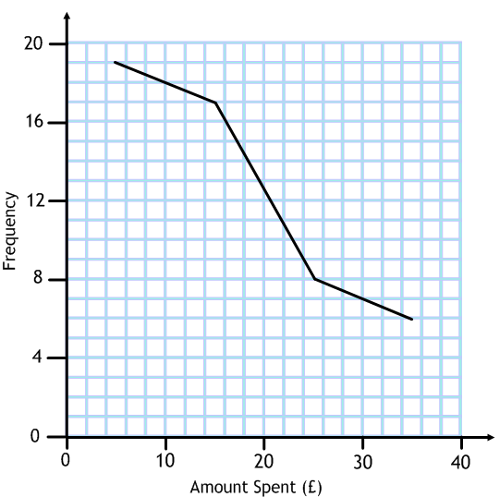
The graph shows how much 50 customers spent in the shop in one transaction.
Estimate the average spend of each customer.
Workings:

