Season 1
William “Billy” Black has been a Food Technology teacher for years, won awards at local bake-offs and is well known for producing the best cakes in the local area. As a result he has been earmarked by visiting aliens to become their planet’s official chef. Billy has therefore decided to sell his wares to provide for his family when he’s gone…
Can you help William “Billy” Black convert the amounts of each ingredient for his giant cake sale?
Recipe 1 – Carrot Cake (serves 4 people)
450ml of vegetable oil
400g plain flour
2 tsp of bicarbonate of soda
5 eggs
½ tsp of salt
2½ tsp of ground cinnamon
525g of carrots
150g of chopped walnuts
Billy wants 8 servings

Recipe 2 – Zebra Cake (serves 5 people)
4 eggs
250g of caster sugar
100ml of milk
250ml of sunflower oil
1 tsp of vanilla extract
475g of self-raising flour
1 tsp of baking powder
25g of cocoa powder
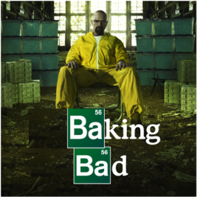
Billy wants 20 servings

Recipe 3 – Chocolate Cake (serves 4 people)
225g of plain flour
350g of caster sugar
85g of cocoa powder
1½ tsp of baking powder
1½ tsp of bicarbonate of soda
2 eggs
250ml of milk
125ml of vegetable oil
2 tsp of vanilla extract
250ml of boiling water
Billy wants 50 servings

Recipe 4 – Victoria Sponge (serves 8 people)
200g of butter
200g of caster sugar
½ tsp of vanilla essence
4 eggs
200g of self-raising flour, sifted
½ jar of raspberry jam
175ml of double cream, whipped
250g of raspberries
3 tbsp of icing sugar
Billy wants 42 servings

Recipe 5 – Dundee Cake (serves 12 people)
175g of softened butter
175g of soft light brown sugar
3 tbsp of orange marmalade
3 eggs
225g of self-raising flour
25g of ground almonds
1 tsp ground mixed spice
400g of mixed dried fruit
75g of glace cherries
2 tbsp whisky or milk
40g of blanched almonds to decorate
Billy wants 8 servings

