Barbie and Ken’s Mathematical Adventures
Barbie and Ken are in their local department store; its floor plan is below:
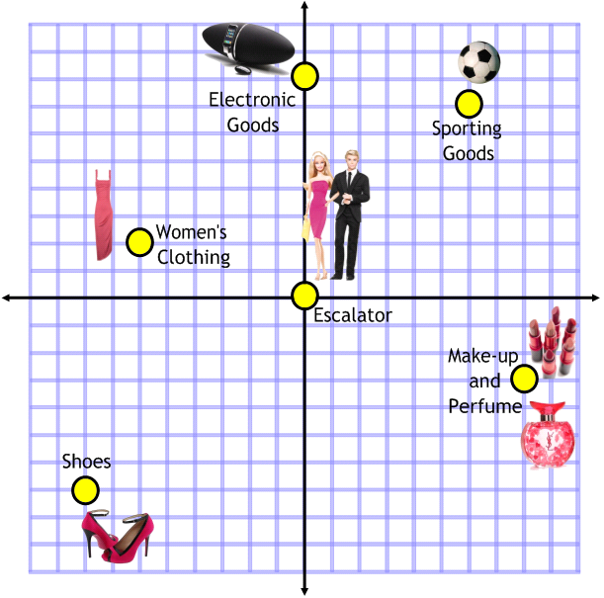
They want to visit the following departments in the following order having arrived on the escalator:
Make-up and Perfume
Shoes
Women’s Clothing
Electronic Goods
Sporting Goods
They will then take the items they desire down the escalator and to the tills.
Write the translation vector of each trip around the department store.

Barbie and Ken take their purchases home. Below is a floor plan of their penthouse:
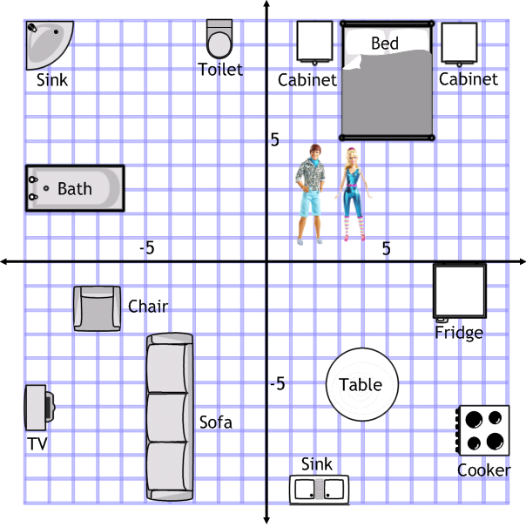
What items lie on the following lines (some may have more than one item on):

- x = 5?
- y = 3?
- x = -4?
- y = -2?
- y = x?
- y = - x?

Barbie has decided to design a T-shirt for Ken using transformations:
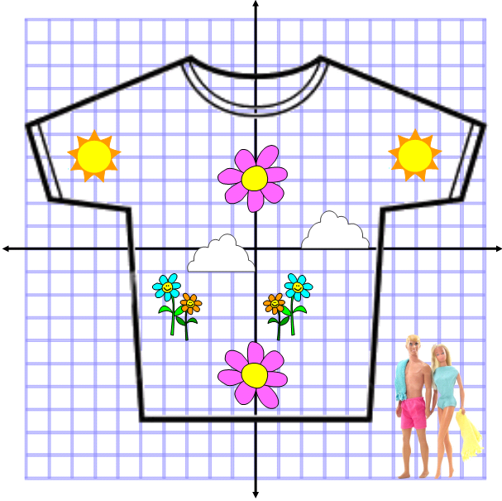
Describe the transformation of each shape.

