Batman’s Tree Diagrams
Batman always carries his weapons in a bag in the Batmobile. In that bag he keeps 5 stun grenades and 3 nets. As soon as he uses an item Robin immediately replaces it so that there are always 5 stun grenades and 3 nets.

Batman just picks an item from the bag and throws it towards the villain each time - he does not know which item it is until that item is thrown.
Copy and complete the tree diagram of Batman's battle with The Riddler in which he used just two weapons:
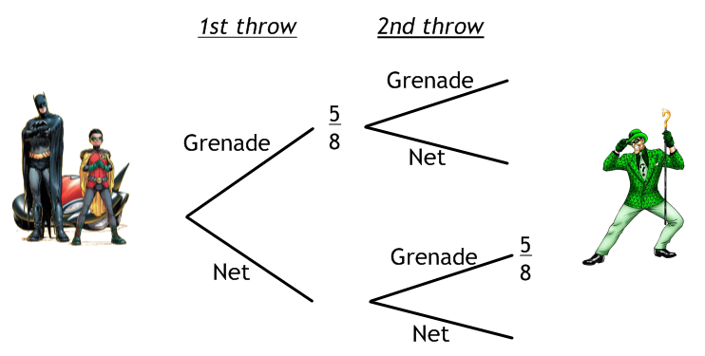
Calculate the probability that Batman throws the following:
- Two grenades.
- One of each weapon (in either order).

Batman also has a battle with The Catwoman, but this time he uses three weapons due to her feline capabilities!
Draw a tree diagram to represent this.
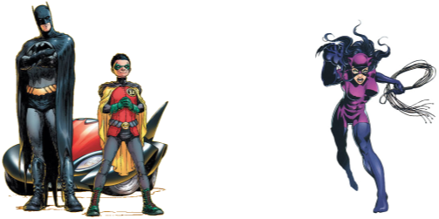

Find the probability that:
- Batman throws three nets.
- Batman throws one net and two grenades, in any order.

Ironman’s Tree Diagrams

Ironman begins every journey with 4 missiles and enough power for 3 electro-pulses. These cannot be replaced, so once they are used, that is it.

Copy and complete the tree diagram below for a battle he had with Madame Masque where Ironman used 2 weapons.
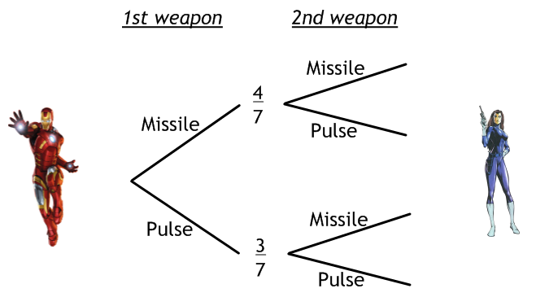
Calculate the probability that Ironman uses the following:
1. Two electro-pulses.
2. One of each weapon (in either order).

Ironman also has a battle with Ultron, but this time he uses three weapons!

Calculate the probability of the following occuring, using a tree diagram to help you:

- Ironman uses three electro-pulses in a row and no missiles.
- Ironman uses an electro-pulse then two missiles.
- Ironman uses two electro-pulses and a missile in any order.
