Batman’s Bearings - Answers
Give the direction and bearing upon which Batman has to travel and use the scale to calculate how far he has gone whilst catching all the criminals.
Note: all directions are North, North East, East, South East, South, South West, West or North West.
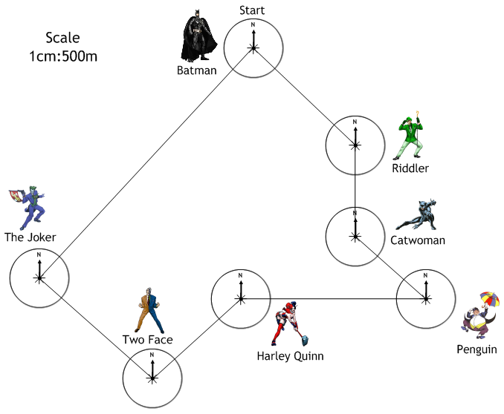
From | To | Direction | Bearing | Distance (m)
Start | Riddler | SE | 135⁰ | 2500
Riddler | Catwoman | S | 180⁰ | 1700
Catwoman | Penguin | SE | 135⁰ | 1700
Penguin | Harley Quinn | W | 270⁰ | 3350
Harley Quinn | Two Face | SW | 225⁰ | 2150
Two Face | The Joker | NW | 315⁰ | 2750
The Joker | Finish | NE | 045⁰ | 5700

