Batman Transformations
Batman is moving around Gotham City but he needs to be told exactly where he’s going (from shape A to shape B) by his butler, Alfred. Help Alfred tell Batman where he’s going by fully describing the transformations below:
Map | Transformation Description
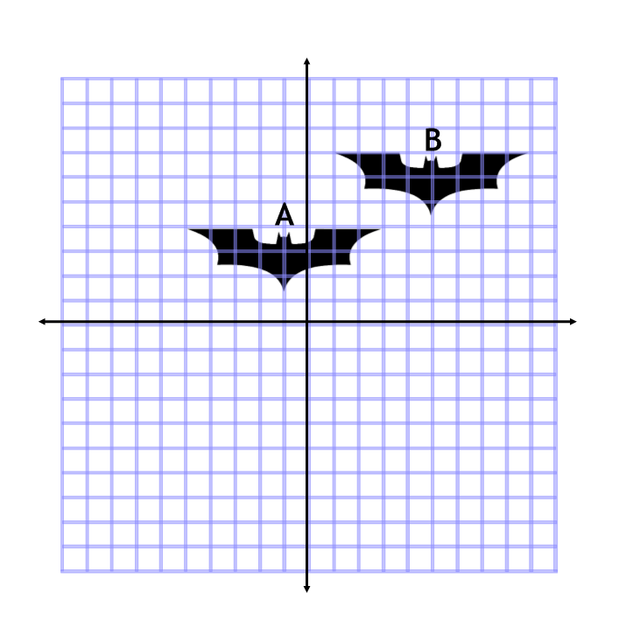
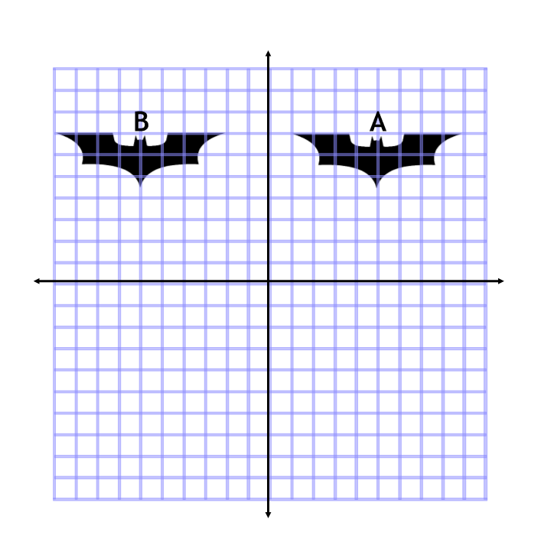
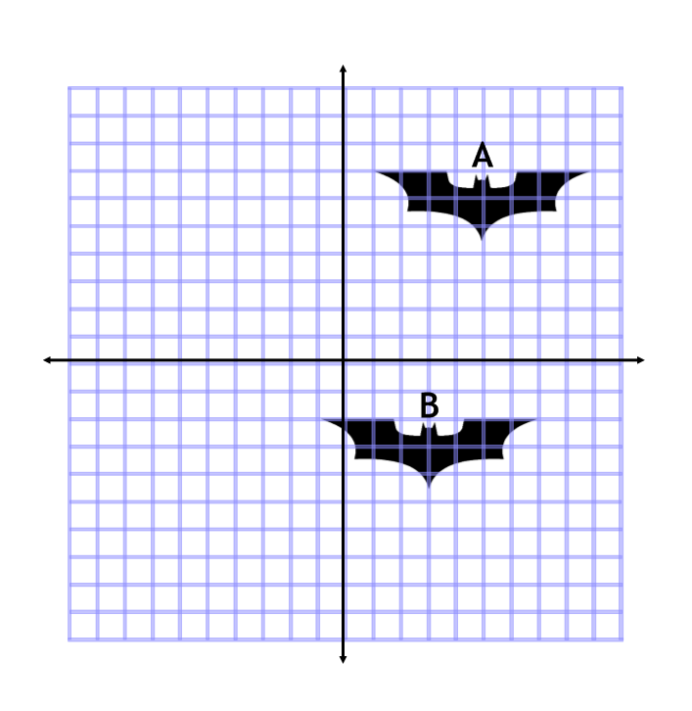
The Bat Signal Enlargements
We can see the Bat Signal above the Gotham skyline, but we need to locate the source. Can you fully describe the enlargements of the Bat Signal (from shape A to shape B) so that Alfred can locate his boss?
View | Description of the Bat Signal
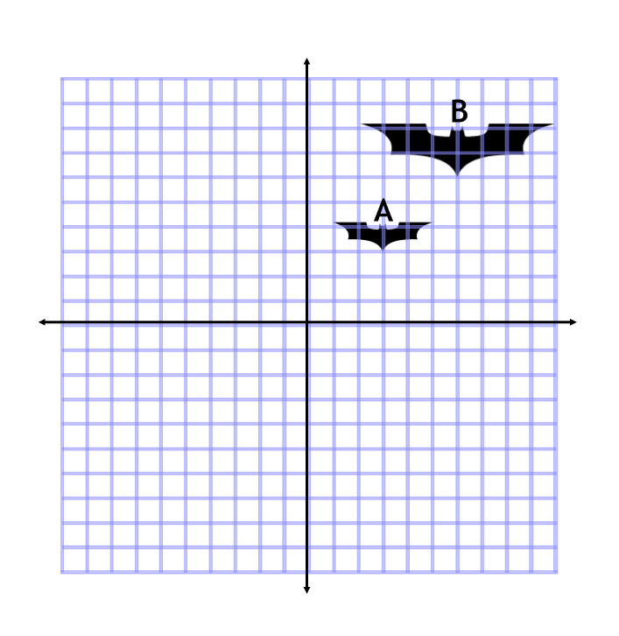
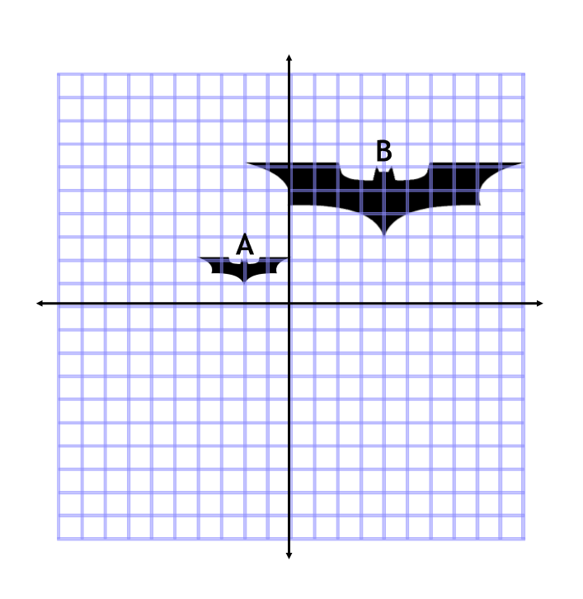

Extension
Can you fully describe the enlargements of the Bat Signal so that Alfred can locate his boss?
View | Description of the Bat Signal
