Batman’s Travel Plans - Answers
Batman is very superstitious when he travels in the Batmobile and will only drive along roads with certain properties on each journey.
Can you help plan his route for each of these journeys?
Remember: He doesn't have to go on the shortest route
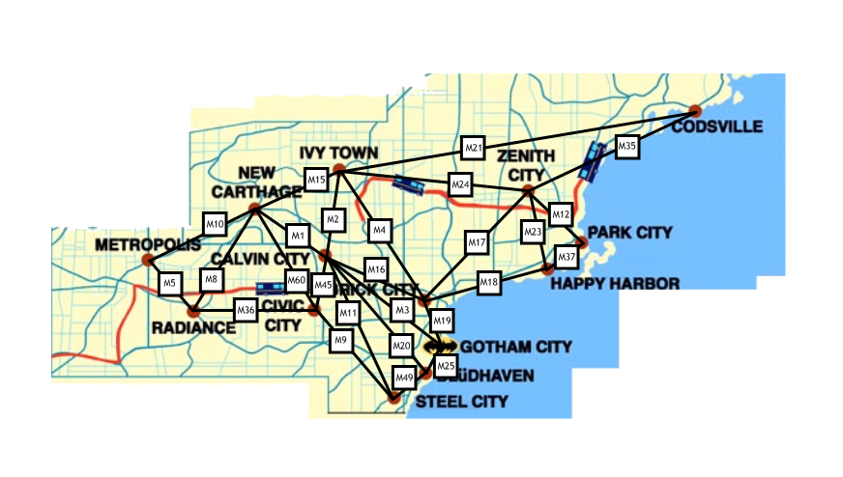
These are the journeys he needs to take:
- Gotham City to Codsville only using odd numbers. M19, M17, M35
- Happy Harbour to Zenith City only using even numbers. M18, M4, M24
- Ivy Town to Radiance only using multiples of 5. M15, M10, M5
- Gotham City to New Carthage only using multiples of 3. M3, M45, M60
- Gotham City to Happy Harbour only using factors of 36. M3, M2, M4, M18
- Park City to Ivy Town only using prime numbers. M37, M23, M17, M19, M3, M2
- Metropolis to Park City only using factors of 120. M10, M15, M24, M12
- Park City to Radiance only using multiples of 3. M12, M24, M15, M60, M36
- Gotham City to Radiance only using square numbers. M25, M49, M9, M36
- Metropolis to Codsville only using triangular numbers. M10, M15, M21
List the roads he needs to drive along to complete his journey.
All journeys can be completed!

