Batman Trigonometry
The Police Commissioner in Gotham City is testing a new way of using the Bat Signal so that the Signal is immediately above the crime that Batman needs to attend.
In order to do this the Commissioner needs to calculate various measurements using trigonometry (he never thought he’d use it, but how wrong he was!).
Help the Commissioner calculate the missing information for the crimes being committed.
The Joker is robbing Gotham’s Bank:
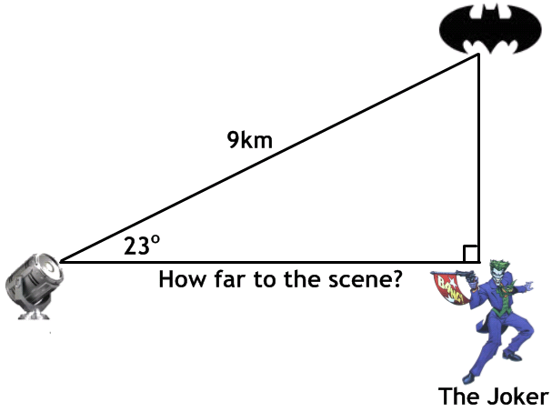
The Riddler is stealing gold bullion from Fort Lox:
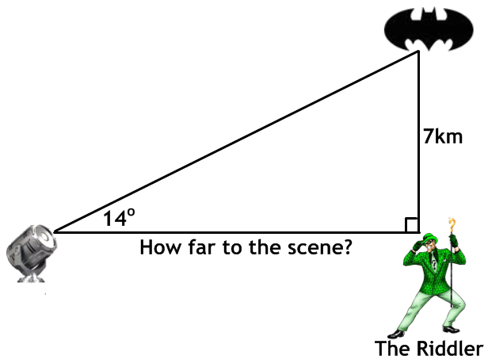

Penguin is planting a bomb at the Gotham High School:
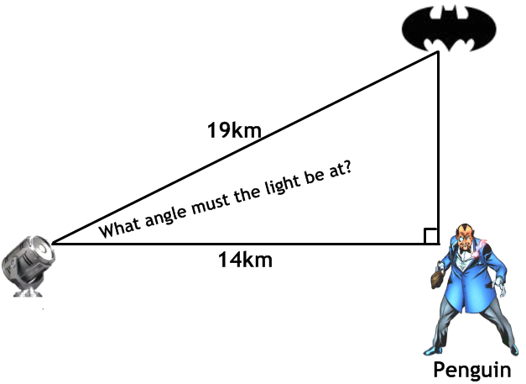
Corrosive Man is spreading fear through Gotham city centre:
