Best Eighties Band – UK Statistics
Four music fans are debating who the best or most successful bands were in the UK during the 1980s. They have collected the information below on the bands but need help analysing it. That’s where you come in…
Question | Aha | Depeche Mode | Frankie Goes To Hollywood | Madness
Picture: |  |  | 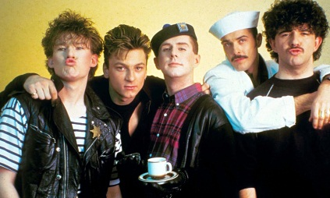
Number of singles: | 12 | 23 | 7 | 19
Singles’ chart positions: | 2, 1, 8, 5, 8, 5, 13, 5, 5, 25, 11, 13 | 57, 11, 8, 6, 12, 18, 13, 6, 21, 4, 9, 16, 18, 18, 15, 28, 17, 16, 22, 21, 60, 22, 13 | 1, 1, 1, 2, 4, 19, 28 | 3, 4, 7, 4, 7, 4, 14, 1, 4, 5, 8, 2, 5, 11, 17, 18, 21, 35, 18
Number of albums: | 3 | 7 | 2 | 5
Albums’ chart positions: | 2, 2, 2 | 10, 8, 6, 5, 4, 10, 5 | 1, 5 | 2, 5, 10, 6, 16
Compilation albums: | - | 1 | - | 2
Chart positon: | - | 6 | - | 1, 29
Approximate worldwide sales (up to 2015) to the nearest million: | 80,000,000 | 100,000,000 | 40,000,000 | 75,000,000
Years they released material: | 1985, 1986, 1987, 1988 | 1981, 1982, 1983, 1984, 1985, 1986, 1987, 1988, 1989 | 1983, 1984, 1985, 1986 1987 | 1980, 1981, 1982, 1983, 1984, 1985, 1986

Make sure that you show and explain all your calculations.
Potential Answers (rounded to 3dp where required):
Calculation | Aha | Depeche Mode | Frankie Goes To Hollywood | Madness
Singles chart position: mean | 8.417 | 18.739 | 8 | 9.895
Singles chart position: median | 6.5 | 16 | 2 | 7
Singles chart position: interquartile range | 12 – 5 = 7 | 21 – 11 = 10 | 19 – 1 = 18 | 17 – 4 = 13
Albums chart position: mean | 2 | 6.857 | 3 | 7.8
Single releases per year | 3 | 2.556 | 1.4 | 2.714
Mean sales per release (all releases ÷ total sales) | 5.333 million | 2.702 million | 4.444 million | 2.885 million

