English Class
Homework
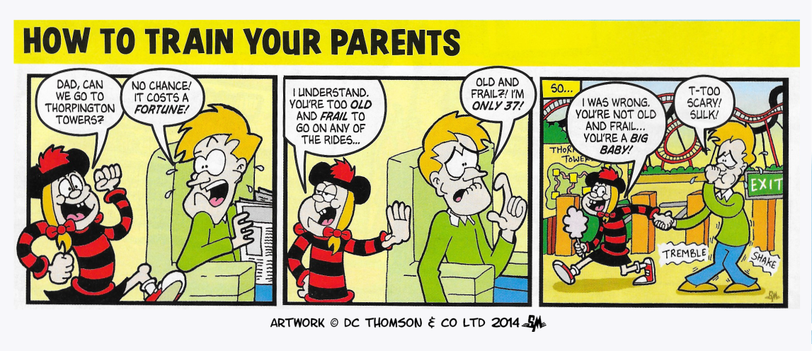

Read the short comic strip above. Retell it as a short story, focussing on correct use of speech punctuation, and ‘show not tell’ to describe the characters.
Remember:
- New speaker, new line.
- Put inverted commas around what is actually spoken.
- Begin speech with a capital letter and remember punctuation before the closing inverted commas: “See you later,” she said as she turned and left.
- If direct speech comes after the information about who is speaking, you should use a comma to introduce the piece of speech, placed before the first inverted comma: He replied, “Too old?”
Look at the layout of dialogue in a reading book if you are unsure.

