The residents of Wetherfield's infamous street are have a few issues with data, namely scatter graphs and what they are telling them.

Can you help them out?

Can you say whether you think each situation will have positive, negative or no correlation?

Situation 1:
The number of fares Lloyd has in his taxi compared to the amount of petrol he uses.
Situation 2:
The number of pairs of socks David has in his wardrobe compared to his age.
Situation 3:
The number of employees at the Underworld factory compared to the total amount of overtime available.

Audrey’s Salon:
Audrey wants to know how much to charge for a cut and blow dry using previous data.
Draw a scatter graph and use it to answer Audrey's questions below:
Cost (in £) | 5 | 8 | 6.5 | 4 | 9 | 12 | 4.5 | 6 | 5.5 | 10
No. of Customers | 42 | 17 | 28 | 51 | 15 | 12 | 45 | 32 | 38 | 8
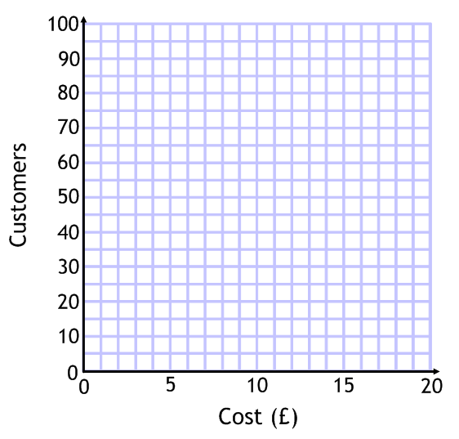
- Audrey wants to charge £7.50. Use your graph to estimate how many customers she could expect at that price.
- Audrey calculates that the salon can reasonably handle 35 cut and blow drys in a day. Use your graph to estimate what she should charge.

Dev’s Corner Shop:
Dev is deciding how long he should keep the The Corner Shop open each day. Use the data below to draw a scatter graph and answer Dev's questions:
Hours Open | 12 | 14 | 8 | 8.5 | 6 | 10 | 16 | 11 | 10.5 | 7.5
Money Taken (£00s) | 8 | 8.5 | 6.2 | 6.4 | 5.1 | 7.6 | 9 | 8.4 | 8.2 | 6.3
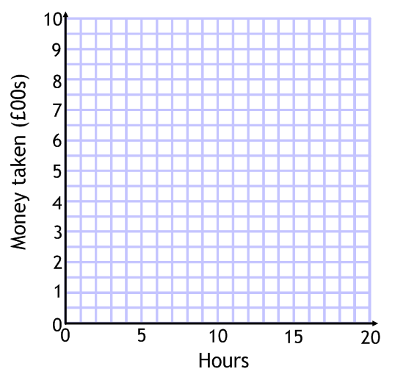
- Dev is thinking of opening for 9 hours. Use your graph to estimate how much money he would take.
- Dev has to take a minimum of £700 per day to cover costs. How long must he keep The Corner Shop open for to cover his costs?
- How long would Dev have to keep The Corner Shop open for to take £1000 per day? Why might your answer not be reliable?
Steve’s New Beer – The Rovers Return:
Steve is wondering what percentage of alcohol to have in the new beer for The Rovers. Use the data and a scatter graph Steve has from previous beers to answer the questions below.
% Alcohol | 4.2 | 3.6 | 3 | 5.1 | 4.4 | 4 | 4.1 | 2.8 | 3.5 | 5.5
Pints drunk per night | 58 | 70 | 97 | 42 | 55 | 71 | 70 | 32 | 78 | 35
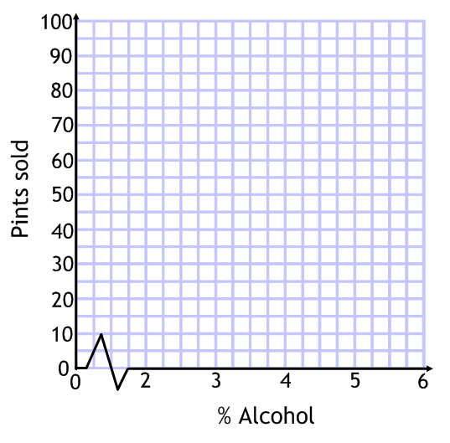
A barrel of beer contains 88 pints and Steve wants to sell a barrel per day.
How strong should the new beer be to sell a barrel per day?
What else does the data tell you?

