**Dinky King 7 – Murrio’s In The Area - Answers**

*The aim of the game:*

Murrio must collect the stars. The number of stars on each level is equal to the level's area in square metres to the nearest whole number.

Each star is worth 30 points.

Dinky King will attempt to stop Murrio but cannot collect stars himself.

Levels are complete when Murrio has collected every star.

*Your task:*

What is the maximum number of points from collecting stars that Murrio can win on each level? (You are given floor plans of each level.)

*Each star = 30 points*

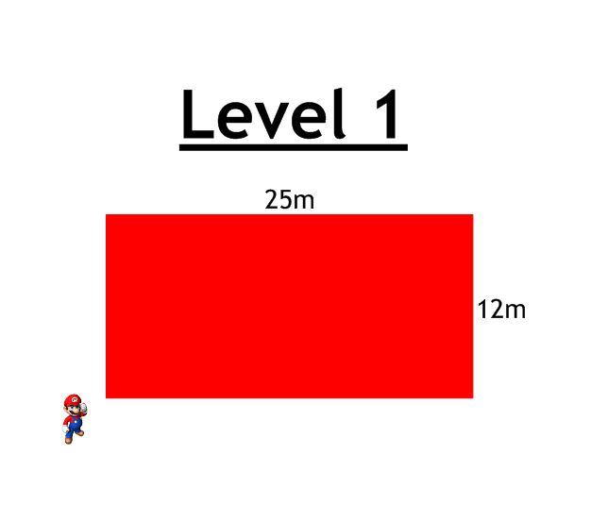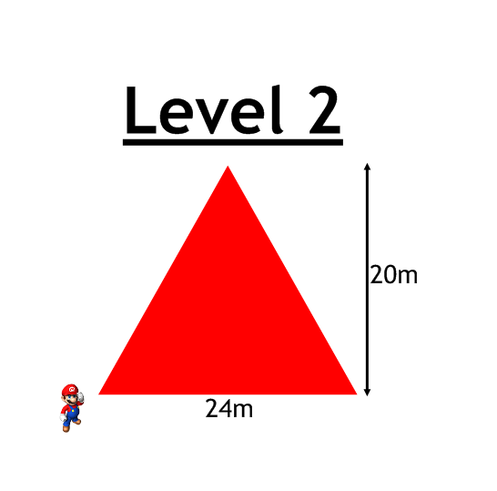

Answer:

300m²

Answer:

240m²

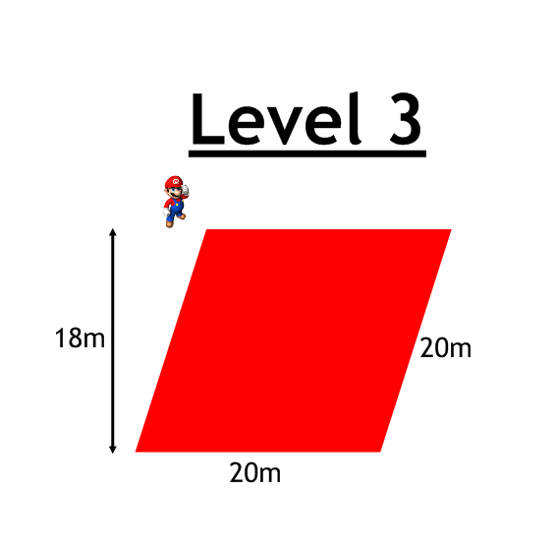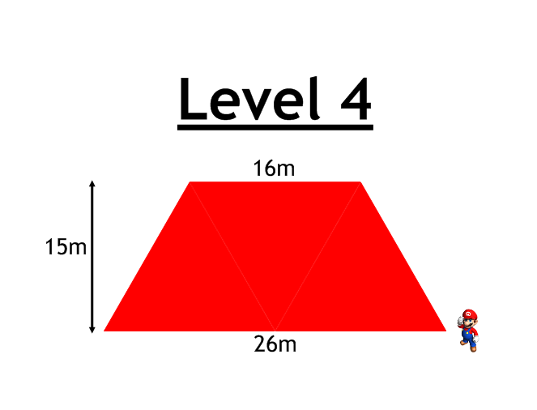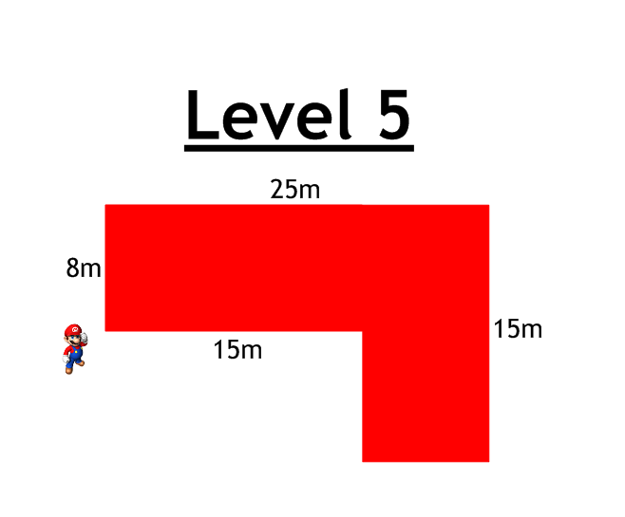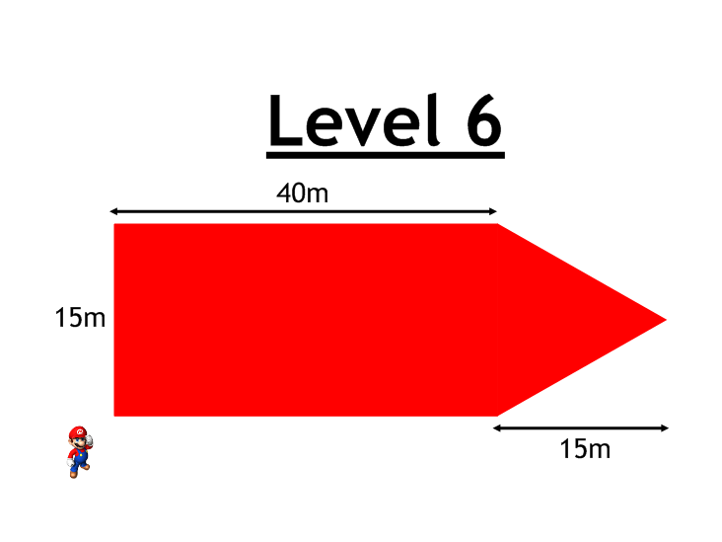

Answer:

713m²

Answer:

270m²

Answer:

315m²

Answer:

360m²

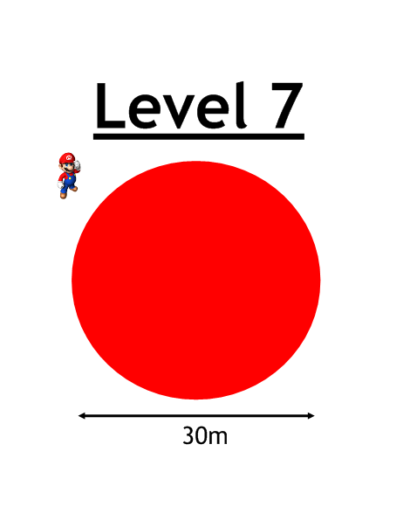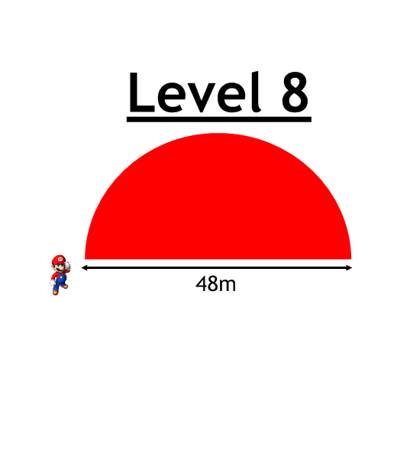

Maximum Points:

Level 1: 9000

Level 2: 7200

Level 3: 10800

Level 4: 9450

Level 5: 8100

Level 6: 21390

Level 7: 21210

Level 8: 27150

Level 9: 37380

Level 10: 21030

Answer:

905m²

Answer:

707m²

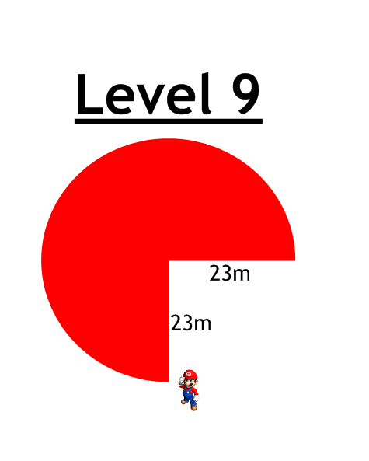

Answer:

1246m²

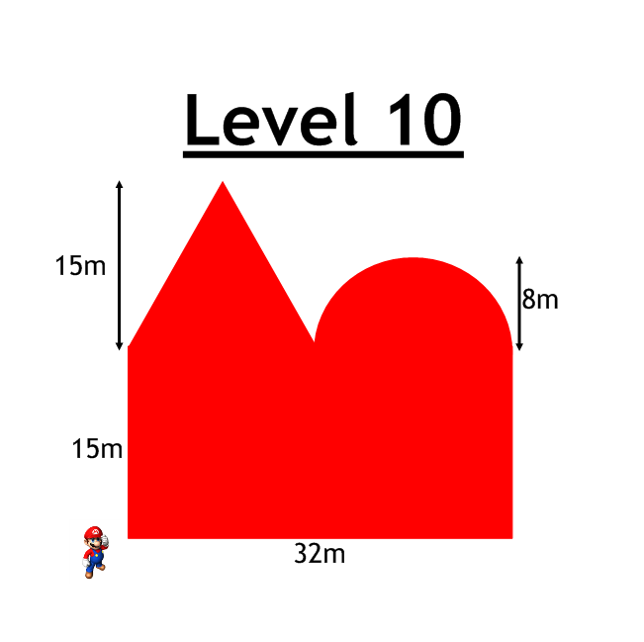

Answer:

701m²

** **