Dinky King 8 – Murrio Turns Up The Volume - Answers
The aim of the game:
In the latest version of the game, Murrio has gone 3D. Murrio must collect the stars. The number of stars on each level is equal to the level's volume in cubic metres to the nearest whole number.
Each star is worth 30 points.
Dinky King will attempt to stop Murrio but cannot collect stars himself.
Levels are complete when Murrio has collected every star.

Your task:
What is the maximum number of points from collecting stars that Murrio can win on each level?
(You are given the dimensions of each level.)
Each star = 30 points

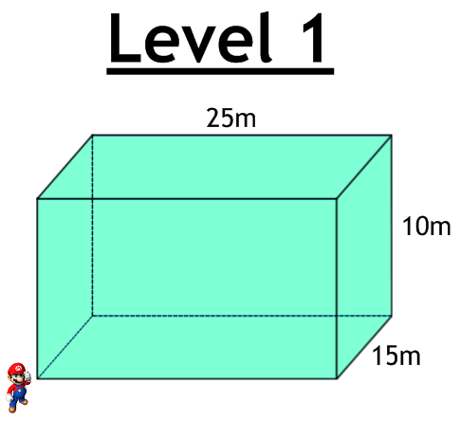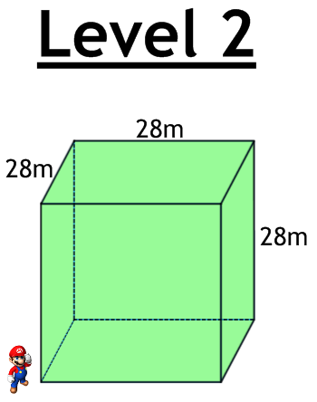
Answer:
21952m³ = 658560 points
Answer:
3750m³ = 112500 points

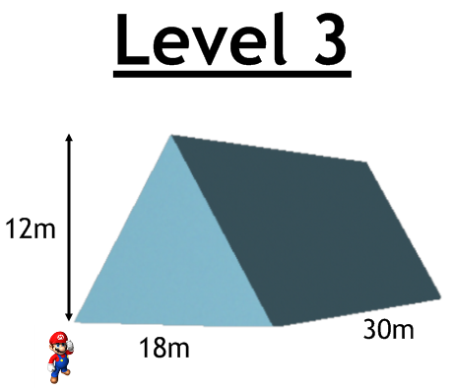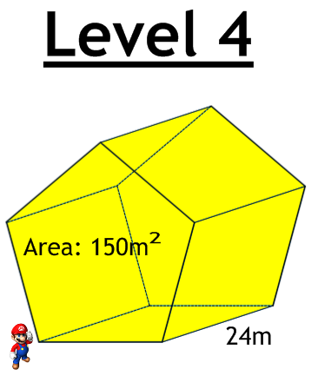
Answer:
3600m³ = 108000 points
Answer:
3240m³ = 97200 points
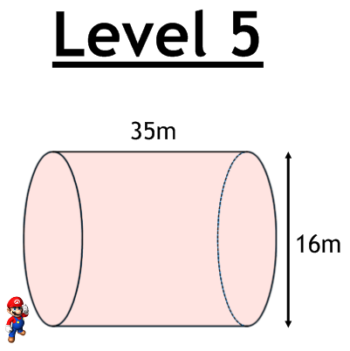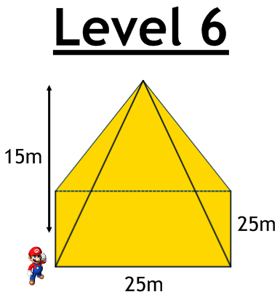
Answer:
3125m³ = 93750 points
Answer:
7037m³ = 211110 points

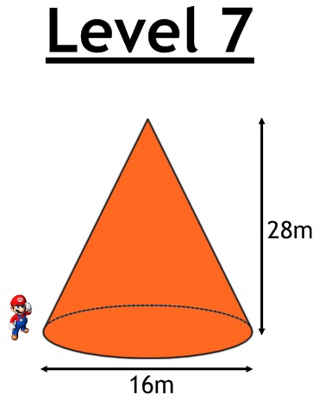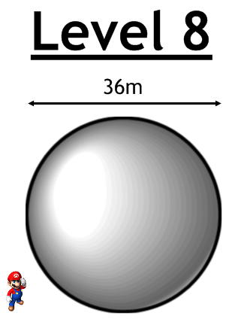
Answer:
24429m³ = 732870 points
Answer:
1877m³ = 56310 points

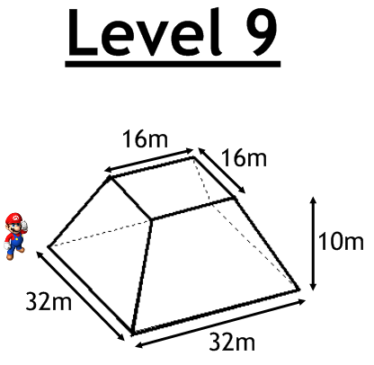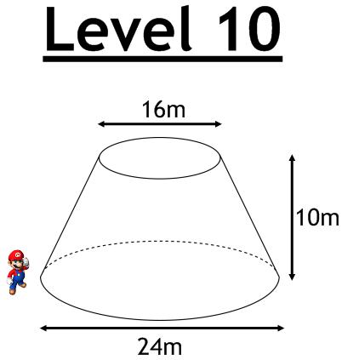
Answer:
3183m³ = 95490 points
Answer:
5973m³ = 179190 points

