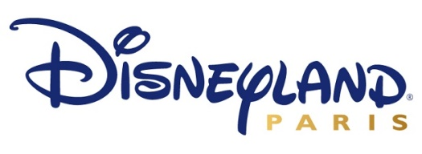

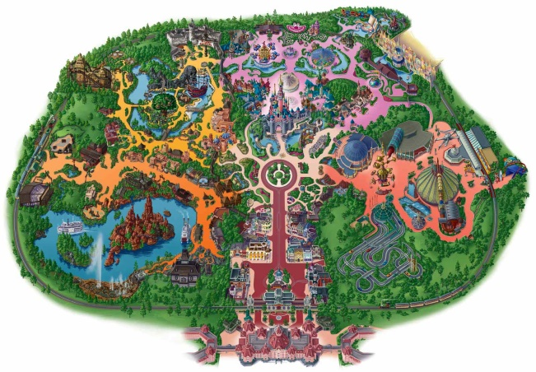
Disneyland Paris is closing sections (lands) of the park in order to install new rides and renovate the surrounding area. Each of the lands has been allocated a specific budget based on its popularity with visitors. In order to make sure that the money is spent effectively, the board of directors have split each land’s budget into portions of money for the following areas rides, amenities and appearance.

They have given you the ratios to show what proportion of the budget should be given to each of the areas (rides, amenities and appearance). You will need to:
- Calculate the amount of money allocated to each of the areas within each land.
- Ensure all money given to the land is spent.
- Provide at least two different possibilities for how the money can be spent.

Items:
The following table shows the cost of different items.

Rides | Cost | Amenities | Cost | Appearance | Cost
Simulator Ride | £27,750 | Street Vendors | £550 | Character Stations | £550
High-Speed Coaster | £65,500 | Sandwich Kiosk | £4,750 | Trees (5x) | £250
Family Ride | £25,250 | Themed Restaurant | £15,000 | Flower Beds | £300
Infant Ride | £19,650 | Toilets (Male, Female and Disabled) | £7,250 | Land Themed Displays | £7,750
Height Drop Ride | £34,450 | Merchandise Store (Small) | £16,750 | Water Fountains | £3,750
Land Themed Ride | £10,500 | Merchandise Store (Large) | £24,000 | Photo Opportunities | £960

Land 1: Fantasy Land

Directors Brief: Fantasy Land is a family and infant attraction area which is one of the most profitable in the entire park. Fantasy Land is the centre of most of our visitor’s attention whose restaurants are just as popular as the rides. High-Speed Coasters have not been installed her previously as it does not fit with the fantasy theme. This is something we want to protect.

Budget: £500,000
Ratio: 5: 4: 1
____________________________________________________________________________________________________________________
Land 2: Discovery Land

Directors Brief: Discovery Land is a step into the future. Filled with a mixture of futuristic rides, themed appearance, simulators and entertainment for all members of a family are what make it a popular land to visitors.

Budget: £336,000
Ratio: 7: 3: 2
____________________________________________________________________________________________________________________
Land 3: Adventure Land

Directors Brief: Adventure Land is a heavily themed area and visitors comment regularly on how impressive the jungle theme is. There is a mixture of rides in this area of the park but few restaurants or stores. Instead, visitors have said that street vendors and sandwich kiosks are good as they do not detract from the atmosphere. This said, the directors are keen to have at least one themed restaurant.

Budget: £450,000
Ratio: 8: 3: 4
____________________________________________________________________________________________________________________
Land 4: Frontier Land

Directors Brief: Frontier Land is another heavily themed area which takes our visitors back in time to the Wild West. Attraction Rides (such as the lake cruise) are a very popular with visitors as it allows them unrivalled views of the park and Frontier Lands major attraction – a high-speed coaster located in the centre of the lake. Visitors have commented on Frontier Lands range of food outlets, stores and mainly thrill seeking rides.

Budget: £340,000
Ratio: 9: 5: 6

Disneyland Paris is closing sections (lands) of the park in order to install new rides and renovate the surrounding area. Each of the lands has been allocated a specific budget based on its popularity with visitors. In order to make sure that the money is spent effectively, the board of directors have split each land’s budget into portions of money for the following areas rides, amenities and appearance.

They have given you the ratios to show what proportion of the budget should be given to each of the areas (rides, amenities and appearance). You will need to:
- Calculate the amount of money allocated to each of the areas within each land.
- Ensure all money given to the land is spent.
- Provide at least two different possibilities for how the money can be spent.

Items:
The following table shows the cost of different items.

Rides | Cost | Amenities | Cost | Appearance | Cost
Simulator Ride | £27,750 | Street Vendors | £550 | Character Stations | £550
High-Speed Coaster | £65,500 | Sandwich Kiosk | £4,750 | Trees (5x) | £250
Family Ride | £25,250 | Themed Restaurant | £25,000 | Flower Beds | £300
Infant Ride | £19,650 | Toilets (Male, Female and Disabled) | £7,250 | Land Themed Displays | £7,750
Height Drop Ride | £34,450 | Merchandise Store (Small) | £16,750 | Water Fountains | £3,750
Land Themed Ride | £10,500 | Merchandise Store (Large) | £24,000 | Photo Opportunities | £960

Land 1: Fantasy Land
Directors Brief: Fantasy Land is a family and infant attraction area which is one of the most profitable in the entire park. Fantasy Land is the centre of most of our visitor’s attention whose restaurants are just as popular as the rides. High-Speed Coasters have not been installed her previously as it does not fit with the fantasy theme. This is something we want to protect.

Budget: £500,000
Ratio: 5: 4: 1
Answer: 250,000: 200,000: 50,000
____________________________________________________________________________________________________________________
Land 2: Discovery Land
Directors Brief: Discovery Land is a step into the future. Filled with a mixture of futuristic rides, themed appearance, simulators and entertainment for all members of a family are what make it a popular land to visitors.

Budget: £336,000
Ratio: 7: 3: 2
Answer: 196,000: 84,000: 56,000
____________________________________________________________________________________________________________________
Land 3: Adventure Land
Directors Brief: Adventure Land is a heavily themed area and visitors comment regularly on how impressive the jungle theme is. There is a mixture of rides in this area of the park but few restaurants or stores. Instead, visitors have said that street vendors and sandwich kiosks are good as they do not detract from the atmosphere. This said, the directors are keen to have at least one themed restaurant.

Budget: £450,000
Ratio: 8: 3: 4
Answer: 240,000: 90,000: 120,000
____________________________________________________________________________________________________________________
Land 4: Frontier Land
Directors Brief: Frontier Land is another heavily themed area which takes our visitors back in time to the Wild West. Attraction Rides (such as the lake cruise) are a very popular with visitors as it allows them unrivalled views of the park and Frontier Lands major attraction – a high-speed coaster located in the centre of the lake. Visitors have commented on Frontier Lands range of food outlets, stores and mainly thrill seeking rides.

Budget: £340,000
Ratio: 9: 5: 6
Answer: 153,000: 85,000: 102,000

