Iron Man Vectors
Iron Man's suit has malfunctioned and will only travel in two directions and for a certain amount of time before it cuts out.
Iron Man can fly between O and A and that vector is a.
If he changes the suit's settings, he can fly from O to B and that vector is b.

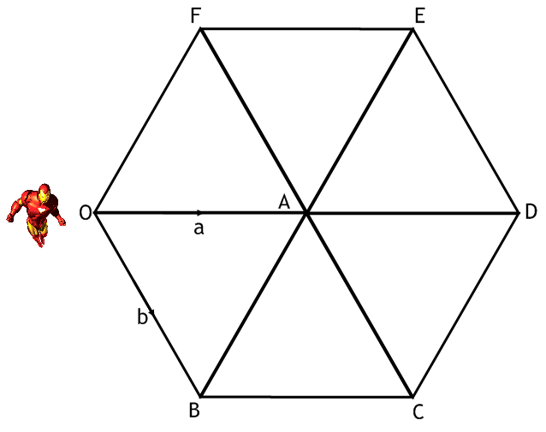
Explain how Iron Man could complete these journeys using the letters a and b:
O to D | A to E | O to C | B to E | B to D

Iron Man's repaired his suit but now it will only travel in a different two directions and for a certain amount of time before it cuts out.
He can do fractions of the distances by manually cutting the engine off.
Iron Man can fly between O and A and that vector is a.
If he changes the suit's settings, he can fly from O to B and that vector is b.

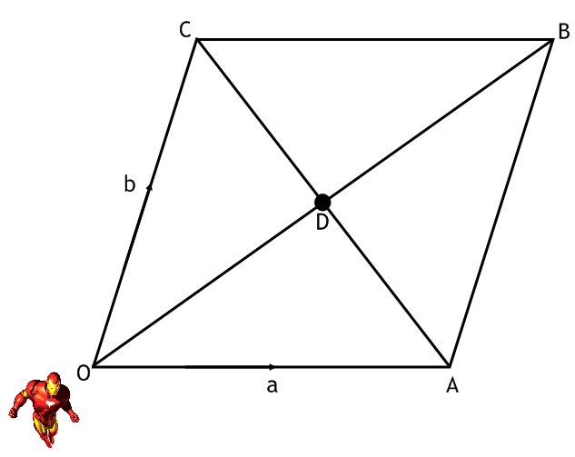
Explain how Iron Man could complete these journeys using the letters a and b:
O to B | A to C | O to D | B to D | C to D

