**Ironman’s Pythagoras and Trigonometry Problems - Answers**

Can you help Ironman perform the calculations he needs to apprehend the villains in each case?

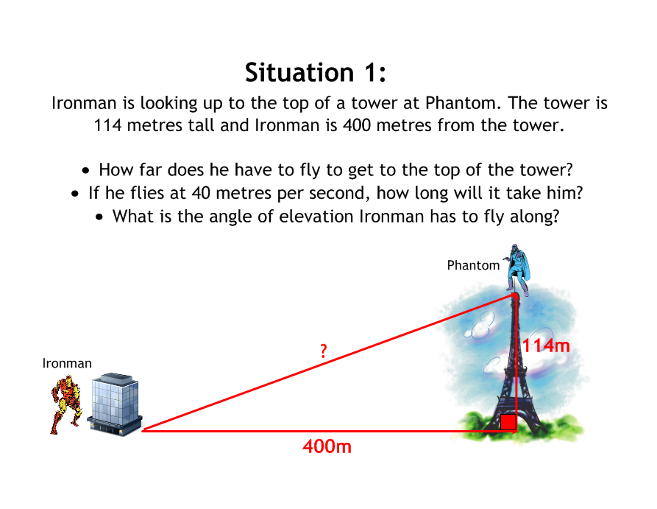

Answers:

1. 416m
2. 10.4 seconds
3. 15.9⁰

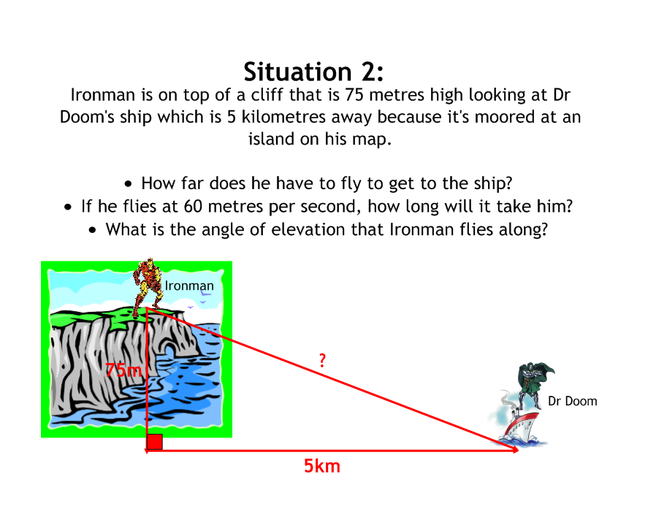

Answers:

1. 5000.6m
2. 83.3 seconds
3. 0.86⁰

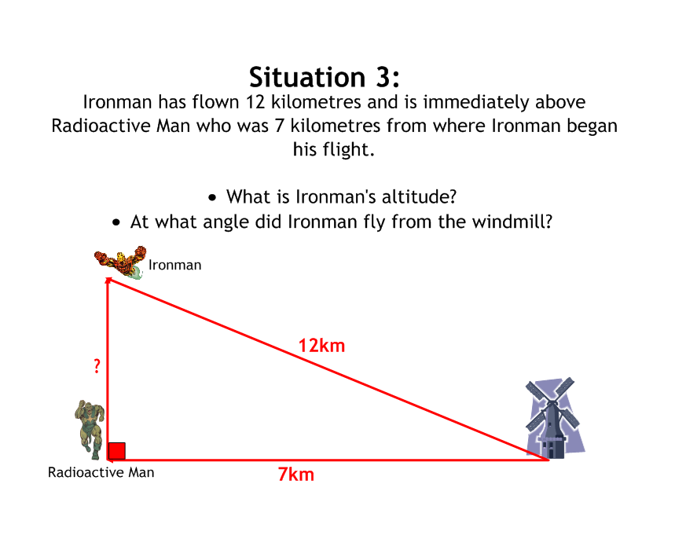

Answers:

1. 9.7km
2. 54.3⁰

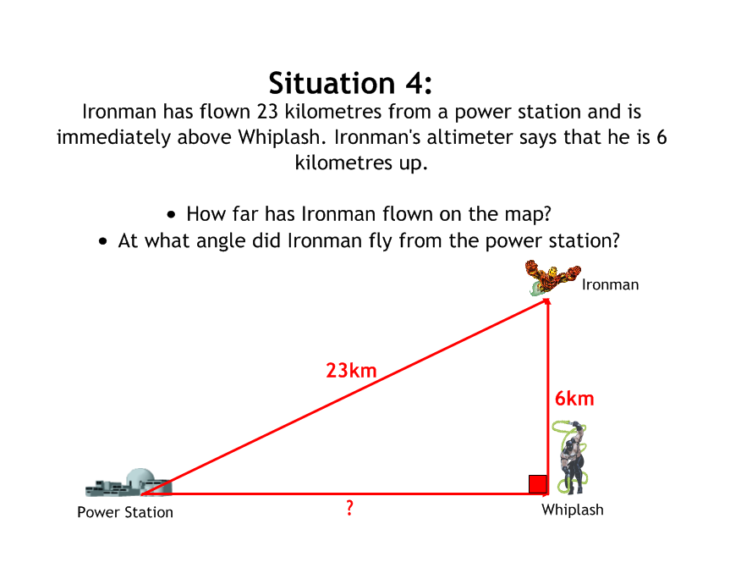

Answers:

1. 22.2km
2. 15.1⁰