Ironman Translations
Ironman has to fly from his base to capture each of these villains. Once a villain is captured he has to fly back to his base to secure them in a holding cell.
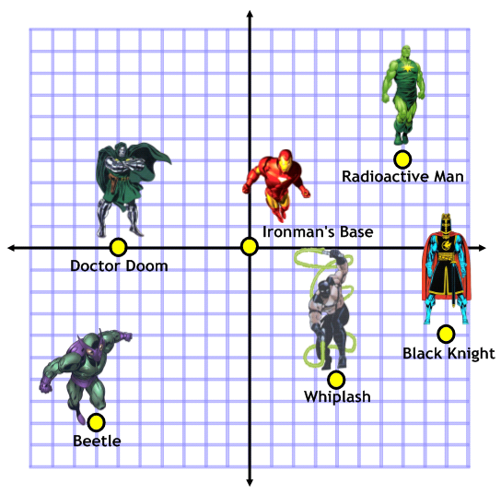
Write the vectors that Ironman has to fly to capture each villain:
Radioactive Man:
Black Knight:
Beetle:
Whiplash:
Doctor Doom:
The Ani-Men Attack!
The Ani-Men, led by Count Nefaria, have let off an explosive device that has knocked Ironman’s co-ordinate grid out of sync. The system thinks that Ironman is now based at (4,8).
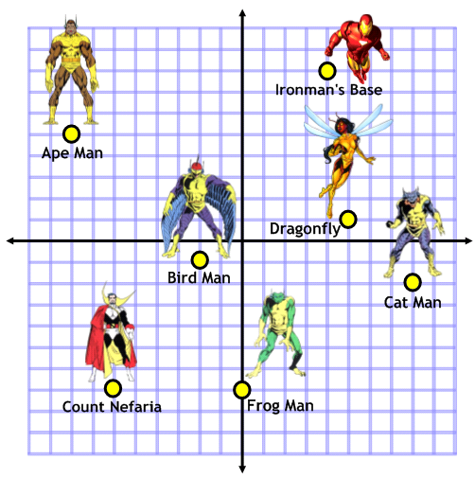
Write the vectors that Ironman has to fly to capture each villain:
Ape Man:
Birdman:
Frog Man:
Dragonfly:
Cat Man:
Count Nefaria:

Extension: Can you calculate the exact distance to each villain so that Ironman can capture them in order from closest first?

