Ironman Translations - Answers
Ironman has to fly from his base to capture each of these villains. Once a villain is captured he has to fly back to his base to secure them in a holding cell.
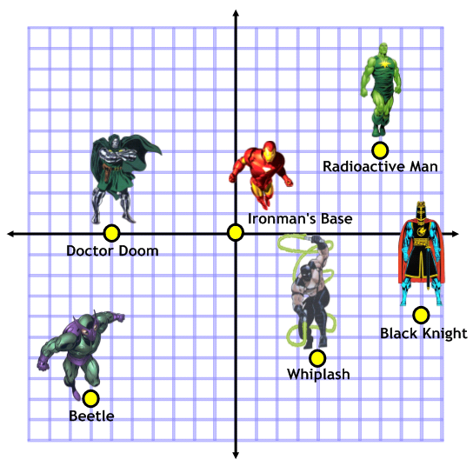
Write the vectors that Ironman has to fly to capture each villain:
Radioactive Man: $\left({7 \atop 4}\right)$
Black Knight: $\left({9 \atop -4}\right)$
Beetle: $\left({-7 \atop -8}\right)$
Whiplash: $\left({4 \atop -6}\right)$
Doctor Doom: $\left({-6 \atop 0}\right)$
The Ani-Men Attack!
The Ani-Men, led by Count Nefaria, have let off an explosive device that has knocked Ironman’s co-ordinate grid out of sync. The system thinks that Ironman is now based at (4,8).
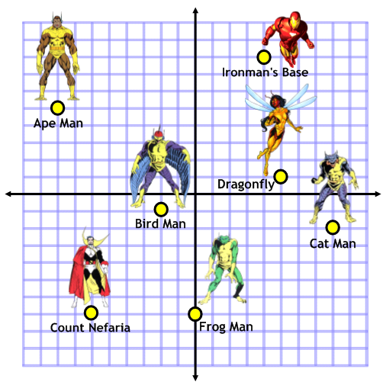
Write the vectors that Ironman has to fly to capture each villain:
Ape Man: $\left({-12 \atop -3}\right)$
Birdman: $\left({-6 \atop -9}\right)$
Frog Man: $\left({-4 \atop -15}\right)$
Dragonfly: $\left({1 \atop -7}\right)$
Cat Man: $\left({4 \atop -10}\right)$
Count Nefaria: $\left({-10 \atop -15}\right)$

Extension: Can you calculate the exact distance to each villain so that Ironman can capture them in order from closest first?

