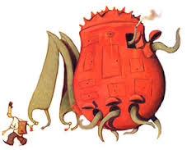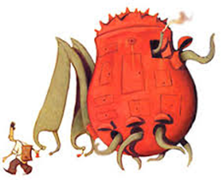

**Shaun finds these bottle tops to add to his collection, but isn’t sure what each one means.**

**Can you work out what the letters y and b mean?**

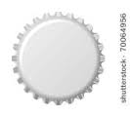          

(26x3) = 2y

Y = (12+17) -6

2B= 34+72

B = 142 x 6

Y= 309 + 120

Y = (27÷3) 4

8b-200=132

3y +17 = 38

4(72÷3)=y

234 ÷ 3 = y

6b = 72 x 4

Y = 4 (23 +72)