**Moshi Monsters love times tables! Can you tell which monster loves which times table?**

3, 6, 9, 12...

27, 30, 33, 36...



14, 21, 28, 35...

49, 56, 63...





5, 10, 15...

45, 50, 55...



8, 12, 16, 20...

28, 32, 36...

20, 30, 40...

70, 80, 90...





8, 16, 24, 32...

56, 64, 72...

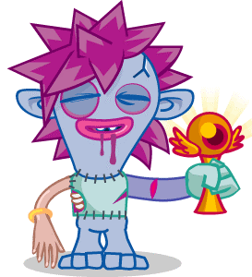

5, 6, 7, 8, 9...

19, 20, 21, 22...

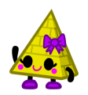

2, 4, 6, 8...

14, 16, 18, 20...



36, 45, 54, 63, 72...



12, 24, 36, 48...

96, 108, 120...

22, 33, 44, 55...

88, 99...