Reading Co-ordinates – Cartoon Characters
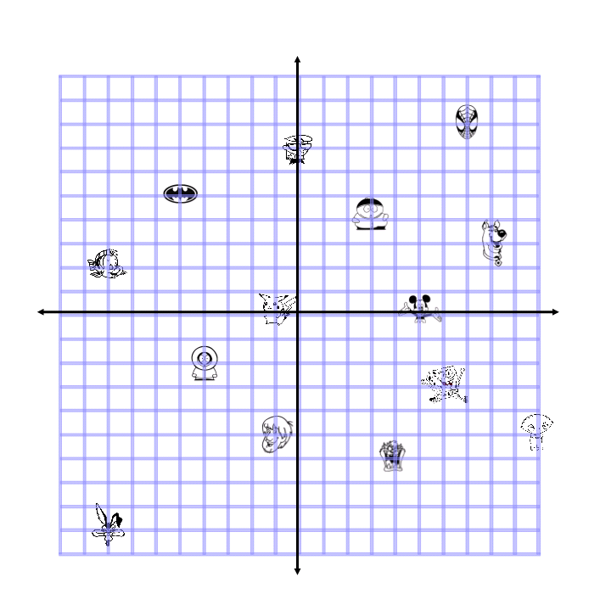

Cartman: ( , )
Spiderman: ( , )
Batman symbol: ( , )
Kenny: ( , )
Spongebob: ( , )
Scooby: ( , )
Shaggy: ( , )
Dexter: ( , )
Flounder: ( , )
Taz: ( , )
Stewie: ( , )
Mickey Mouse: ( , )
Pikachu: ( , )
Wile – E – Coyote: ( , )

