Scatter Graphs
How well correlated are you with your classmates?
For the following hobbies/interests, rank them with a 1 for your least favourite and 10 for your most favourite. (Use each number once)
- Playing music b) Sleeping c) Watching tv d) Playing sport e) Reading f) Internet g) Cinema h) Shopping i) Listening to music j) Dancing

Hobby | a | b | c | d | e | f | g | h | i | j
(x) Me
(y)Friend

Now plot your data on the chart below. Make a line of best fit. Are you positively correlated? Negatively correlated?
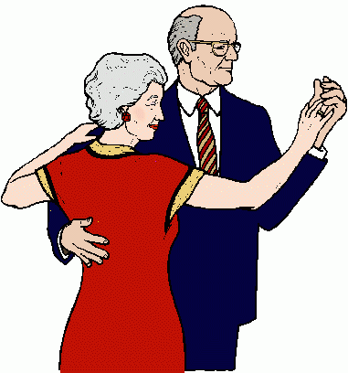
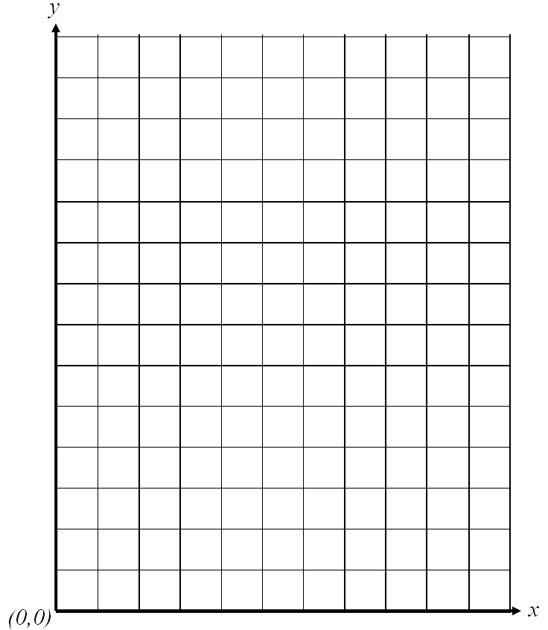
Repeat the same test with someone else (if you are a girl, ask a boy and vice versa!)
Hobby | a | b | c | d | e | f | g | h | i | j
Me
Friend

