2D Shape Challenge
How many squares are there?
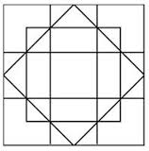

2D Shape Challenge

How many triangles are there?
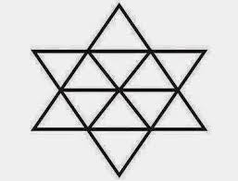
3D Shape Challenge
How many cubes are there?
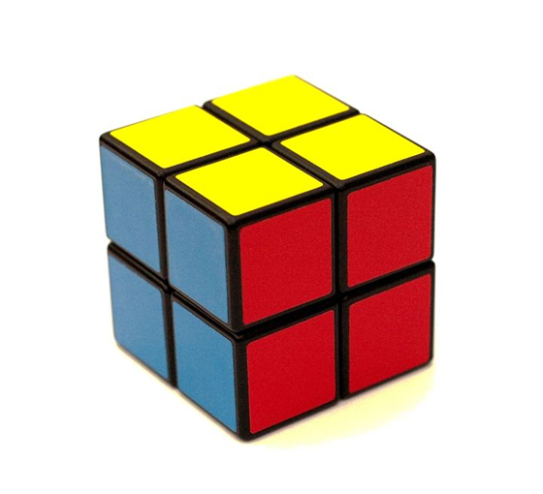

3D Shape Challenge
How many cubes are there?
