Properties of 2D Shapes
Picture | Shape | How many sides? | Curved or straight sides? | How many vertices? (corners) | Other
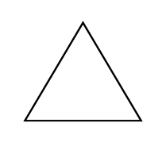 | Triangle | 3 | Straight | 3
 | Square |  |  |  | 4 right angles
Rhombus or
Diamond
 | Rectangle
 | Parallelogram
 | Trapezium
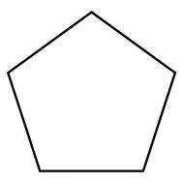 | Pentagon
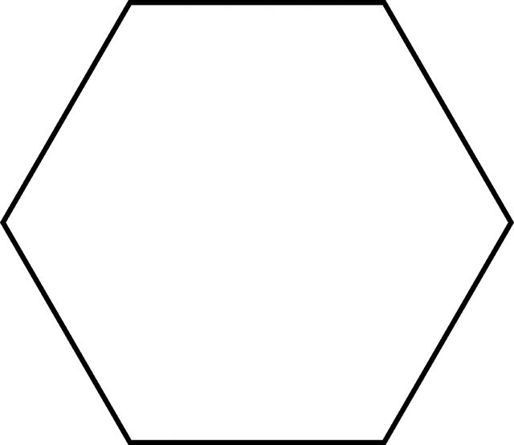 | Hexagon
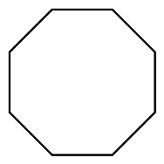 | Octagon
 | Circle
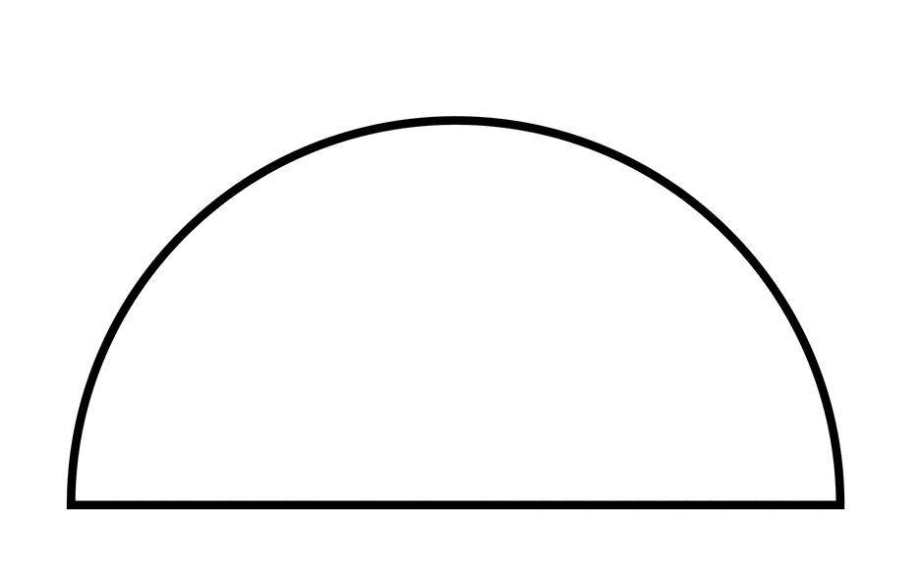 | Semicircle
Ellipse or
Oval
Properties of 3D Shapes
Picture | Shape | Edges  How many?  Curved or straight? | How many vertices? (corners) | Faces  How many?  Curved or flat?  What 2D shape?
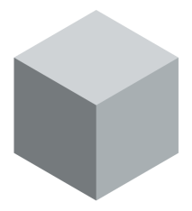 | Cube | 12 straight edges | 8 | 6 flat square faces
 | Cuboid
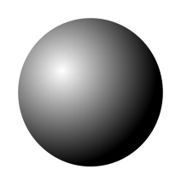 | Sphere
 | Hemisphere
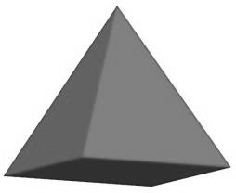 | Square-based  Pyramid
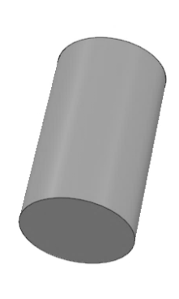 | Cylinder
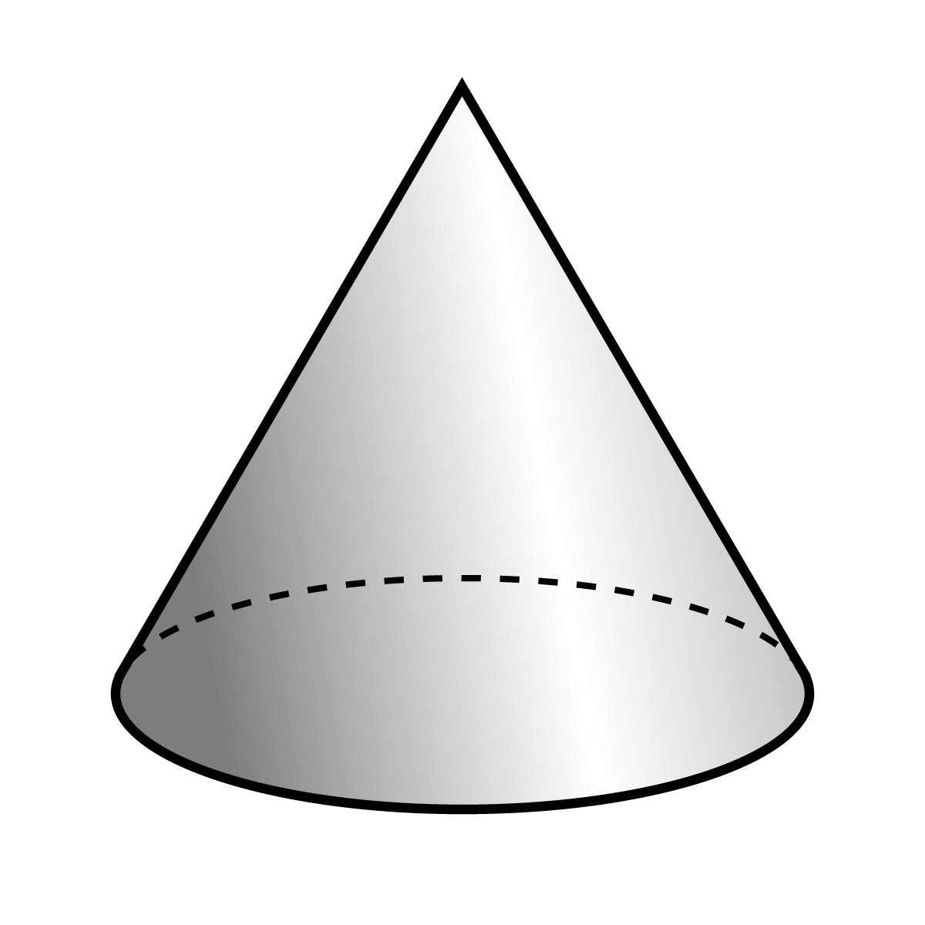 | Cone
 | Prism

Properties of 3D Shapes
Picture | Shape | Edges  How many?  Curved or straight? | How many vertices? | Faces  How many?  Curved or flat?  What 2D shape?
 | Cube | 12 straight edges of equal length | 8 | 6 flat square faces
 |  |  |  | 2 flat square faces and 4 flat rectangular faces
 |  | 0
Square-based
Pyramid
 |  | 2 curved edges
 |  |  | 1 | 1 flat circular face and  1 curved face
 | Prism

Properties of 2D Shapes
Picture | Shape | How many sides? | Curved or straight sides? | How many vertices? (corners) | Other
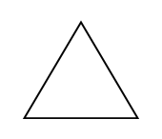 | Triangle | 3 | Straight | 3
 |  | 4 |  |  | All sides the same length
 |  |  |  |  | 4 right angles
 | Trapezium |  |  |  | Quadrilateral
 |  |  |  | 5
 | Hexagon
 |  | 8
 |  |  |  | 0
1 curved
1 straight
 | Ellipse

