Sharing Moshi Monsters
A group of children are going to share some Moshi Monsters:

- Annie wants the multiples of 5.
- Brad wants the factors of 36.
- Courtney wants the multiples of 3.
- Dylan wants the factors of 60.
- Ellie wants the prime numbers.
- Freddie wants the square numbers.

Who gets the most, do the children have to share any and are any left over?
Number |  |  | Number |  |  | Number
1 | Burnie |  | 13 | 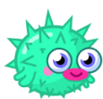  Blurp |  | 25 | 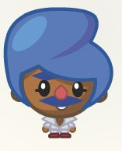  Bobbi Singsong
2 | 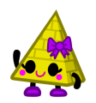  Cleo |  | 14 | 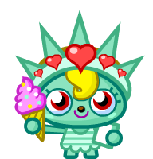  Liberty |  | 26 | 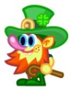  O’Really
3 | DJ Quack |  | 15 | 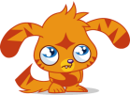  Katsuma |  | 27 | Gabby
4 | Furi |  | 16 | Cali |  | 28 | 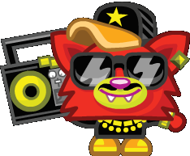  Blingo
5 | 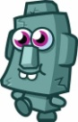  Rocky |  | 17 | Honey |  | 29 | I.G.G.Y.
6 | 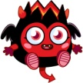  Diavlo |  | 18 | 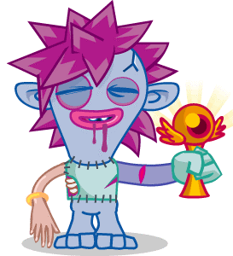  Zommer |  | 30 | Flumpy
7 | Cutie Pie |  | 19 | Purdy |  | 31 | 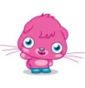  Poppet
8 | 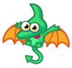  Gurgle |  | 20 | Coolio |  | 32 | 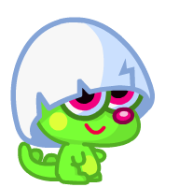  Pooky
9 | 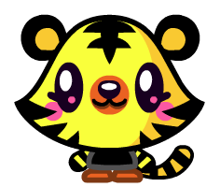  Jeepers |  | 21 | Ecto |  | 33 | Wallop
10 | Tiki |  | 22 | Waldo |  | 34 | Gigi
11 | 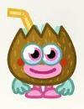  Coco Loco |  | 23 | Luvli |  | 35 | 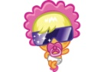  Lady GooGoo
12 | General Fuzuki |  | 24 | Dustbin Beaver |  | 36 | Nipper

Some more Moshi Monsters have appeared, but a random selcetion.
Who should get each one, are any shared and are any left over this time?
(Check the numbers carefully!)
Number |  |  | Number |  |  | Number
37 | 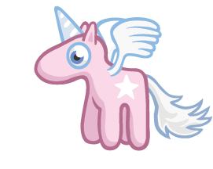  Angel |  | 54 | Fumble |  | 72 | Lady Meowford
40 | 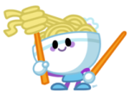  Suey |  | 55 | Furnando |  | 73 | Wurly
42 | 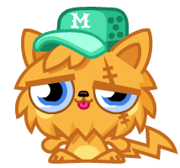  Ginger Snap |  | 57 | Tomba |  | 75 | 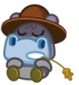  Humphery
44 | 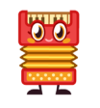  Plinky |  | 60 | Tiamo |  | 90 | White Fang
45 | Mini Ben |  | 62 | Fizzy |  | 91 | Nipper
46 | 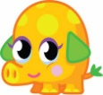  Mr Snoodle |  | 63 | Peppy |  | 100 | 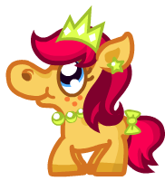  Priscilla
48 | Penny |  | 67 | Scamp |  | 108 | 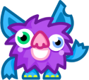  Shambles
50 | Ting-A-Ling |  | 69 | Roxy |  | 150 | 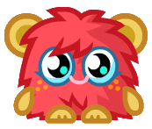  Scarlet O’Haira
51 | 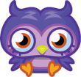  Professor Purplex |  | 70 | Squidge |  | 225 | 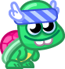  Shelby
53 | 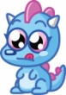  Snokum |  | 71 | Shi Shi |  | 500 | Stanley

Who didn’t get any from this selection of Moshi Monsters?
Explain how you got all your answers.

