Spiderman Bearings
Spidey is on the lookout for criminals.
Can you help him by finding the three-figure bearing of each criminal on the grid?
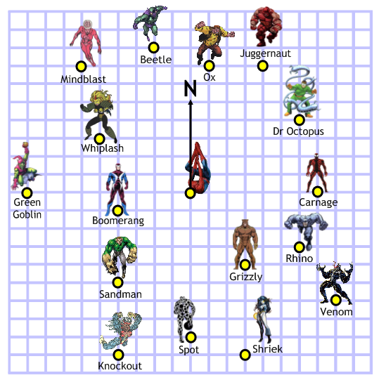

Ox: …………………………⁰
Juggernaut: …………………………⁰
Dr Octopus: …………………………⁰
Carnage: …………………………⁰
Rhino: …………………………⁰
Venom: …………………………⁰
Grizzly: …………………………⁰
Shriek: …………………………⁰
Spot: …………………………⁰
Knockout: …………………………⁰
Sandman: …………………………⁰
Boomerang: …………………………⁰
Green Goblin: …………………………⁰
Whiplash: …………………………⁰
Mindblast: …………………………⁰
Beetle: …………………………⁰

