Spiderman Fractions
Spiderman has so many enemies that they have organised themselves into groups in a bid to beat him.
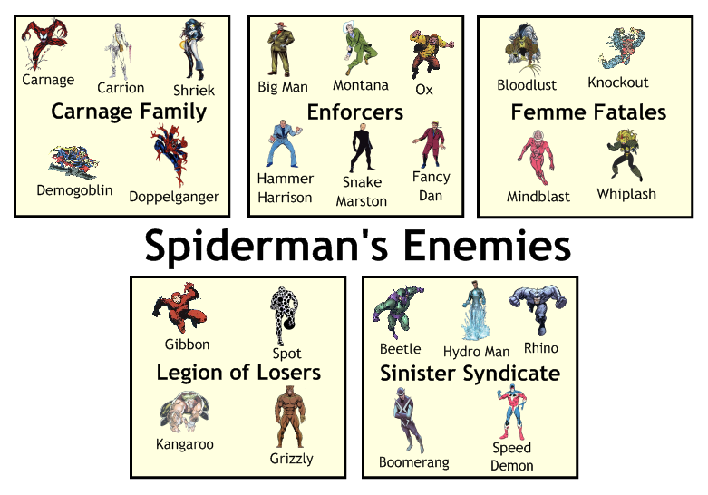
- What fraction of Spiderman's enemies are members of the Carnage Family?

- What fraction are in the Legion of Losers?

- What fraction are either in the Enforcers or the Sinister Syndicate?

- What fraction are not in the Femme Fatales?

- What fraction of Spiderman's enemies have names beginning with B?

- Half the Femme Fatales are in jail. How many Femme Fatales are in jail?

- Spiderman caught a third of the Enforcers. How many of the Enforcers did he catch?

- Of all Spiderman's enemies, two thirds have been caught. How many is that?

- A quarter of all Spidey's enemies are retiring. How many are retiring?

- The rest are still at large - how many are still at large?

How much of a full turn has Spidey turned in each case?

