Spiderman Fractions - Answers
Spiderman has so many enemies that they have organised themselves into groups in a bid to beat him.
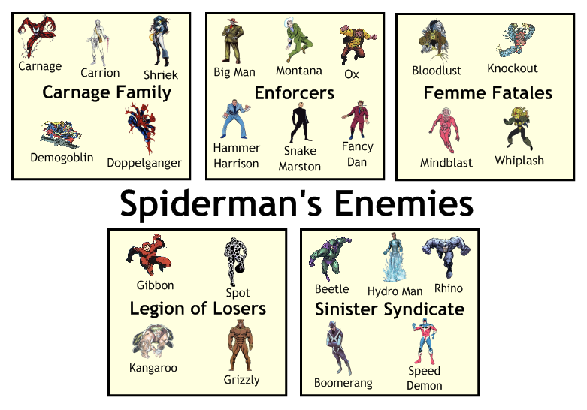
$$\frac{5}{24}$$
- What fraction of Spiderman's enemies are members of the Carnage Family?
$$\frac{1}{6}$$
- What fraction are in the Legion of Losers?
$$\frac{11}{24}$$
- What fraction are either in the Enforcers or the Sinister Syndicate?
$$\frac{20}{24}$$
- What fraction are not in the Femme Fatales?
$$\frac{1}{6}$$
- What fraction of Spiderman's enemies have names beginning with B?
2
- Half the Femme Fatales are in jail. How many Femme Fatales are in jail?

- Spiderman caught a third of the Enforcers. How many of the Enforcers did he catch?
2
16
- Of all Spiderman's enemies, two thirds have been caught. How many is that?
6
- A quarter of all Spidey's enemies are retiring. How many are retiring?
2
- The rest are still at large - how many are still at large?

How much of a full turn has Spidey turned in each case?

$$\frac{1}{4}$$

$$\frac{1}{3}$$

$$\frac{3}{4}$$

$$\frac{1}{6}$$

$$\frac{5}{12}$$

$$\frac{2}{5}$$

