Spiderman Rotations
Spiderman always attaches the web he swings by to the origin (0,0) as it is a solid base.
Below Spidey is practising swinging to land in certain positions:
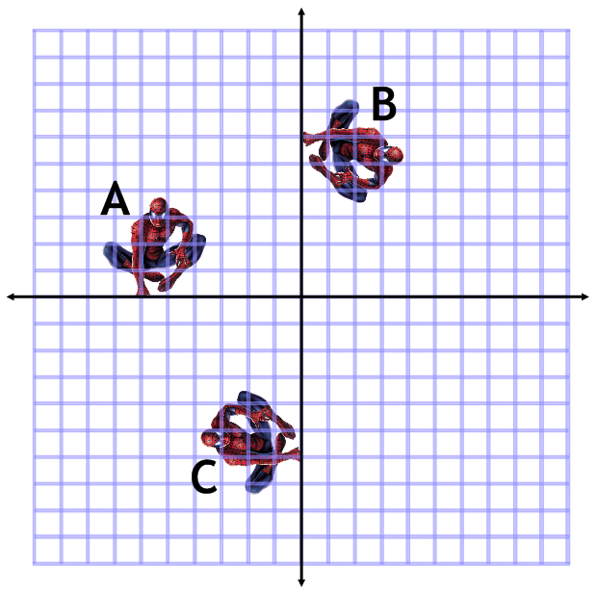
Complete the descriptions of the rotations Spidey uses during his practise session:
Start | Finish | Centre | Direction | Degrees turned
A | B | (0,0)
B |  | (0,0) | Clockwise | 180°
 | A | (0,0) | Anti-Clockwise | 270°
C |  | (0,0) | Clockwise | 90°

Spidey needs to put his practise to the test. In order the catch a criminal Spidey needs to be in the same quadrant (part of the grid) as them.
Describe what rotations Spidey must perform in order to capture each criminal:

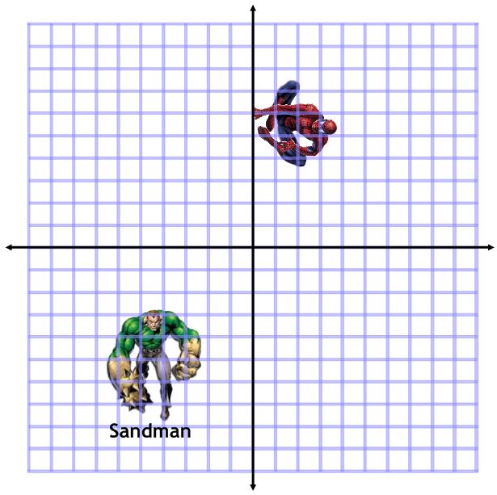
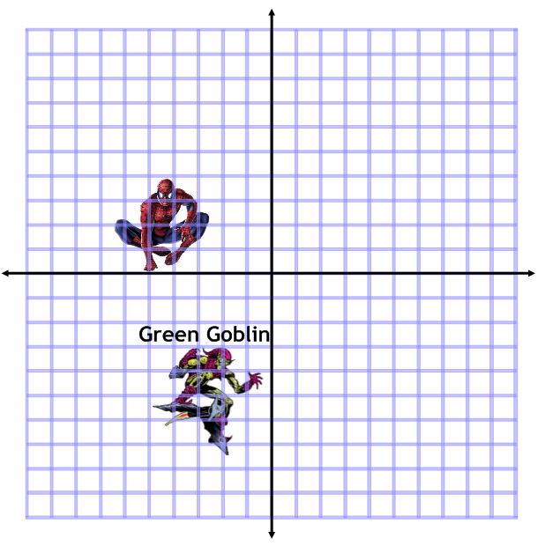

Extension – describe all of them but don’t forget where Spidey’s got to and the order they have to be captured in:

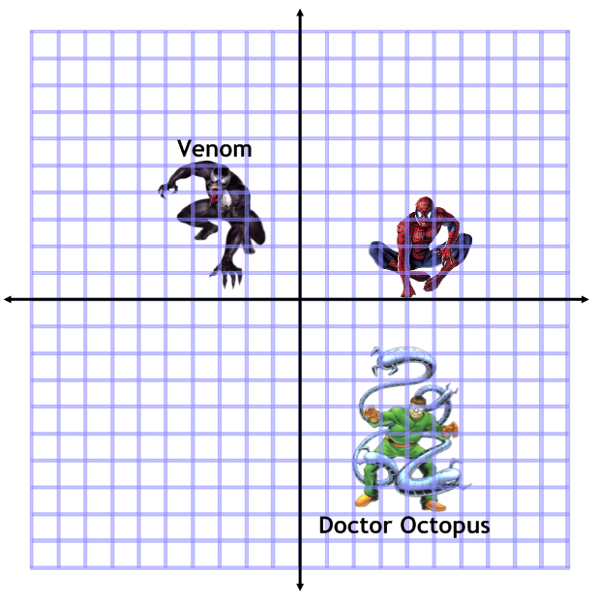
In this order:
- Doctor Octopus
- Venom
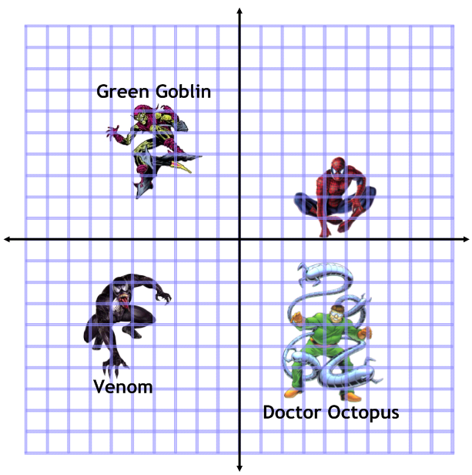
In this order:
- Venom
- Doctor Octopus
- Green Goblin

