Spiderman Transformations
Describe what transformation Spidey has use to get from position A to B to C, and tell our superhero how he could have got straight from position A to C and saved energy to fight crime.
Make sure that you fully describe each transformation, using equations or names of lines.
Spidey’s Movements | Description
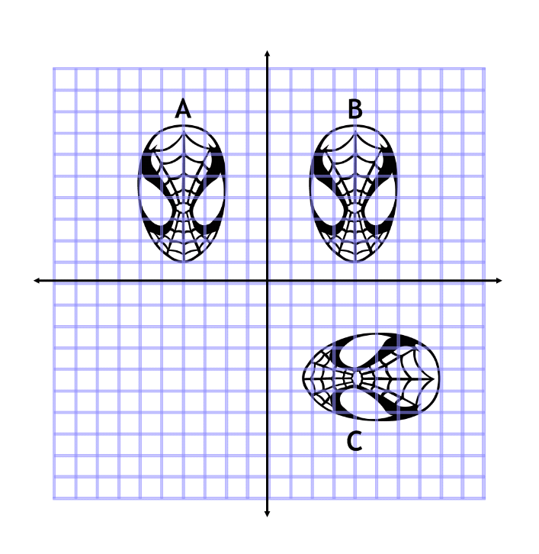
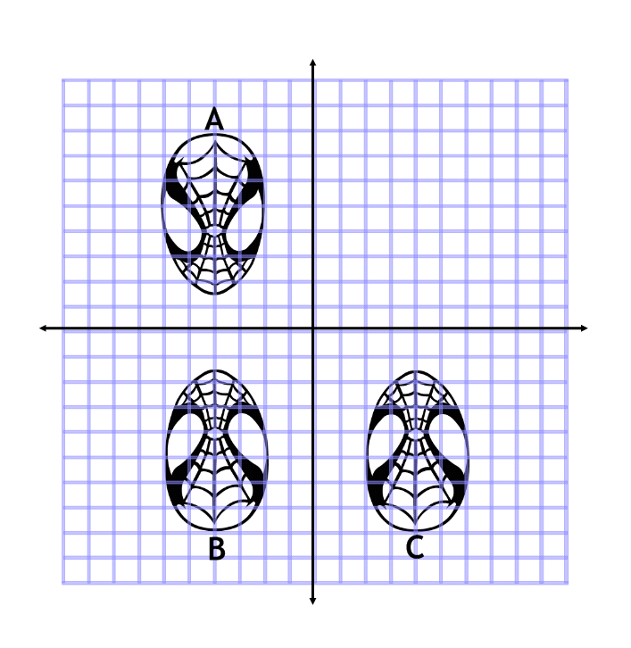
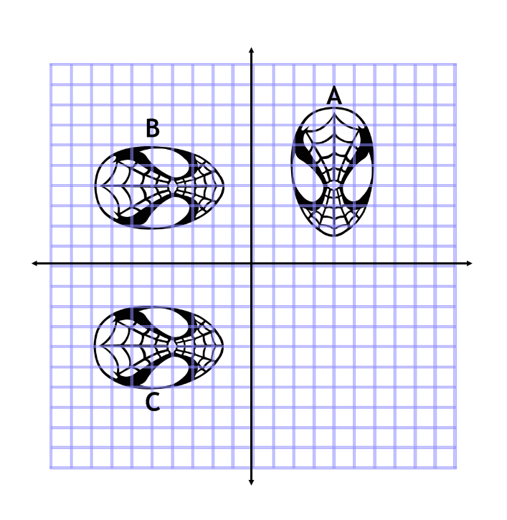

Extension
Our hero has got a bang on the head and is performing some slightly trickier transformations.
Make sure that you fully describe each transformation, using equations or names of lines.
Spidey’s Movements | Description
