Steading Solutions
LI: mathematically reason to solve problems.
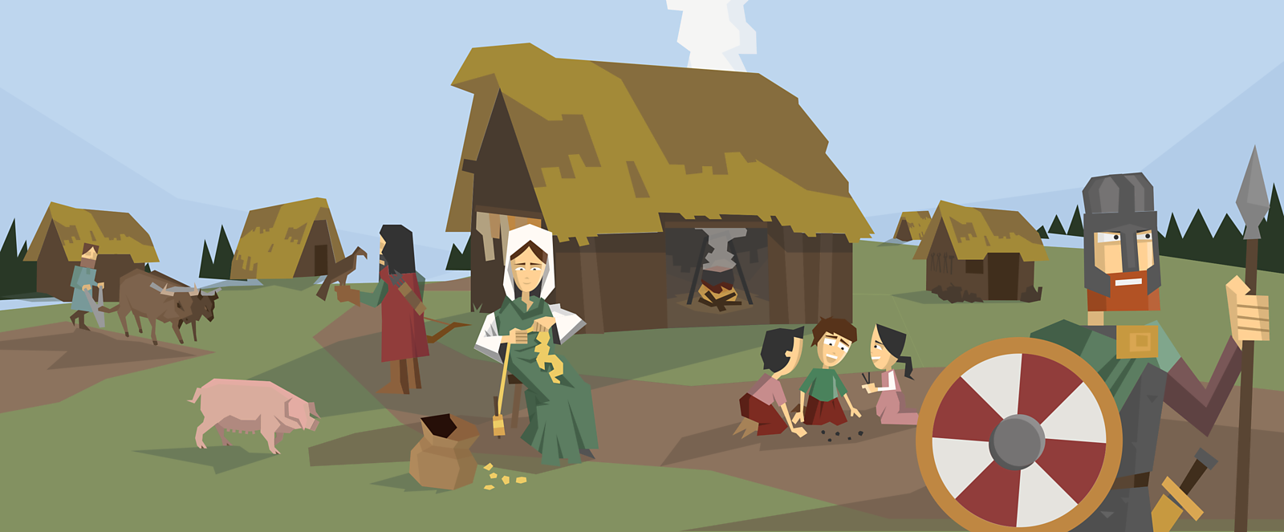
Problem adapted from NRich “Pied Piper” task for Key Stage 2.
Whilst tending to his animals, Tostig looked out across the new steading in which he lived. The journey from Scandinavia had been a perilous one but now he had arrived and begun to settle into life on the isle of Briton. During the invasion, he had been fortunate enough to bring some of his life stock with him – they would surely keep his family (and the other civilians in the steading) fed for some time.

Task: Use the evidence below to find all the possible combinations of the live stock, and steading-dwellers, that Tostig had could see as he attended his duties.

Scenario 1: Whilst looking across the steading, having milked the cows and tended to the ducks, Tostig watched as the children of the steading played in the pig pens. Whilst he watched, smile upon his face, as he counted one-hundred and fifty legs. How many children and pigs could Tostig see playing in the pens?

Number of legs: ………………………………………………………..
Creatures seen: ………………………………………………………….

Scenario 2: Sometime later, Tostig could see both horses and chickens roaming around the far enclosure. He knew that the total number of legs possessed by the horses and chickens was six-hundred. How many horses and chickens were in the enclosure?

Number of legs: ………………………………………………………..
Creatures seen: ………………………………………………………….

Scenario 3: During the invasion of Northern Briton, Tostig had been part of a warrior group sent to defeat resistance in local villages. Many men and horses were sent over during the invasion to secure land. He knew there to be seven-hundred and fifty legs in total. How many men and horses could have participated in the invasion?

Number of legs: ………………………………………………………..
Creatures seen: ………………………………………………………….

---------------------------------------------------------------------------------------------------------------------------------------

Example: Tostig wandered down to the nearby stream to collect water. He could see the steading’s goat drinking the cool water and the ducks swimming freely on the water. He knew that the total number of duck and goat legs was sixty. How many ducks and goats could he see?

Number of legs: 60
Creatures seen: ducks (2 legs) and goats (4 legs)

There could be:
- 5 goats (5 x 4 = 20) and 20 ducks (20 x 2 = 40) = 20 + 40 = 60
- 10 goats (10 x 4 = 40) and 10 ducks (10 x 2 = 20) = 40 + 20 = 60
- 6 goats (6 x 4 = 24) and 18 ducks (18 x 2 = 36) = 24 + 36 = 60
- 12 goats (12 x 4 = 48) and 6 ducks (6 x 2 = 12) = 48 + 12 = 60

