Superman Co-ordinate Pythagoras
Calculate the exact distances Superman has to fly for each leg of his journey below to engage the villains who are making trouble.
He flies in a straight line from point to point in the order below and each square is a kilometre.
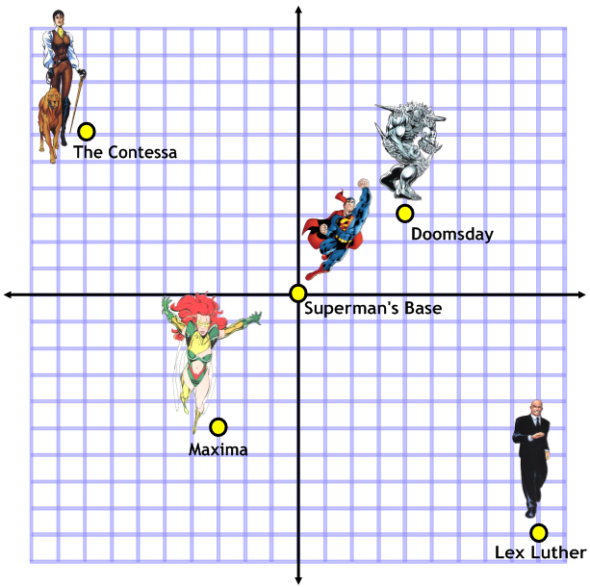
Base to Doomsday:
…………………………………………………………………………………………………………………………
Doomsday to The Contessa:
…………………………………………………………………………………………………………………………
The Contessa to Maxima:
…………………………………………………………………………………………………………………………
Maxima to Lex Luther:
…………………………………………………………………………………………………………………………

Iron Man Co-ordinate Pythagoras
Calculate the exact distances Iron Man has to fly for each leg of his journey below to engage the villains who are making trouble.
He flies in a straight line from point to point in the order below and each square is a kilometre.
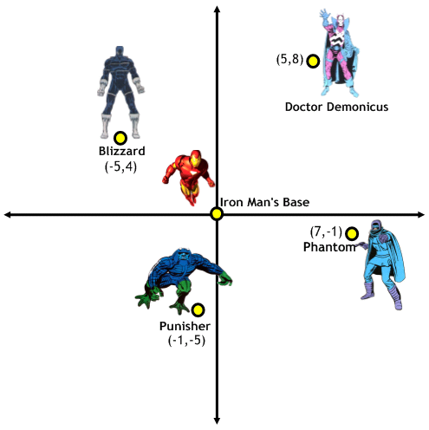
Base to Phantom:
…………………………………………………………………………………………………………………………
Phantom to Punisher:
…………………………………………………………………………………………………………………………
Punisher to Blizzard:
…………………………………………………………………………………………………………………………
Blizzard to Doctor Demonicus:
…………………………………………………………………………………………………………………………

