Superman Bearings
Superman has to fly around his local area catching criminals.
He obviously flies in a straight line between cities and towns as that is the quickest route.
Use bearings and a scale of 1cm:50km to describe Superman's journey on a particularly busy day for crime fighting.
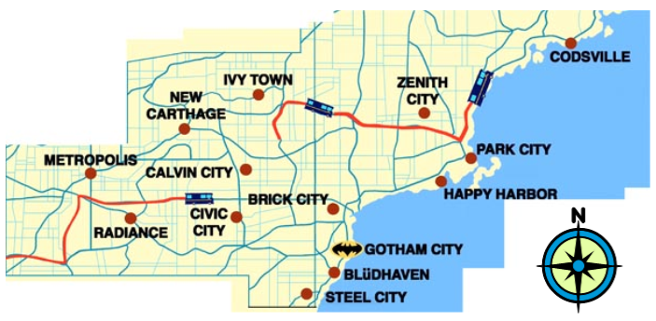
Leg | Start | Finish | Distance | Bearing
1 | Metropolis |  | 220km | 107⁰
2 |  | Ivy Town
3 | Ivy Town |  | 240km | 096⁰
4 |  | Steel City
5 | Steel City |  | 200km | 333⁰
6 |  | Metropolis
