Superman Bearings - Answers
Superman has to fly around his local area catching criminals.
He obviously flies in a straight line between cities and towns as that is the quickest route.
Use bearings and a scale of 1cm:50km to describe Superman's journey on a particularly busy day for crime fighting.
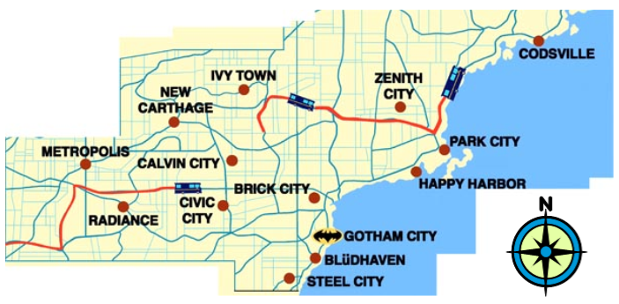
Leg | Start | Finish | Distance | Bearing
1 | Metropolis | Civic City | 220km | 107⁰
2 | Civic City | Ivy Town | 180km | 010⁰
3 | Ivy Town | Zenith City | 240km | 096⁰
4 | Zenith City | Steel City | 310km | 213⁰
5 | Steel City | Calvin City | 200km | 333⁰
6 | Calvin City | Metropolis | 225km | 270⁰
