Superman’s Journey
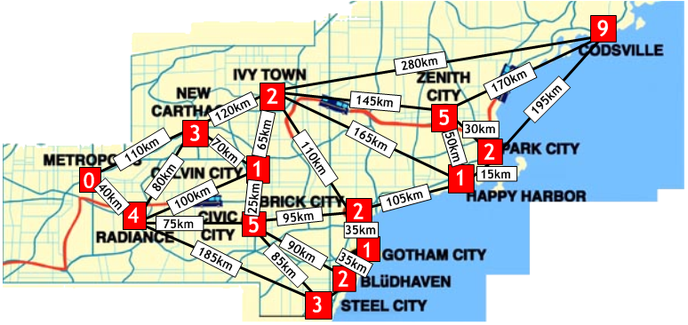
Remember:
- Start and finish at Metropolis
- Catch as many criminals as you can.
- Fly a maximum of 1000km.
- Once you have caught the criminals in one place, you can’t catch them again!

