The Walking Dead – Season 4 – Area and Perimeter
Deputy Crimes and his fellow survivors have found a group of mathematically shaped islands which are unaffected by the zombie apocalypse as they were uninhabited. Can you find the area of each island so Deputy Crimes can start populating each one?
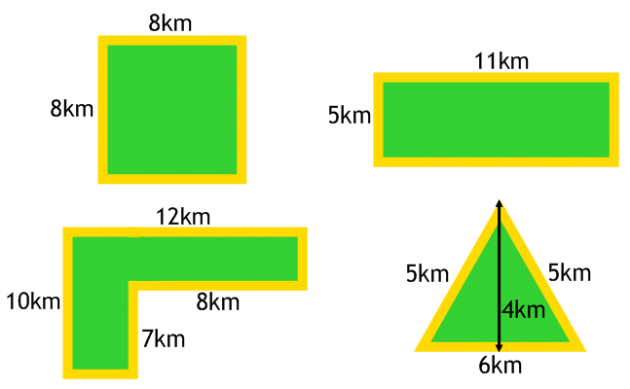
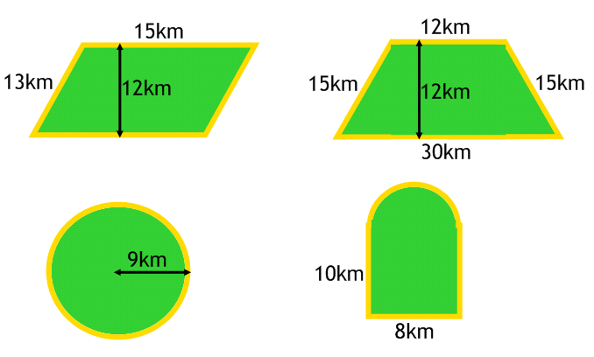
Each person requires 3km² in order to grow enough food to survive. How many people can survive on each island?
There are rumours of a zombie invasion from the mainland so Deputy Crimes has decided to put a fence around the perimeter of the island. How much fencing is required for each island?

Deputy Crimes has decided that all the survivors are better off in one place. He has found the deserted island below. He wants to house 120 survivors on the island and has 150km of fencing.
Is this possible if each person requires 3km² of land and the fencing must go around the whole island? You must show your workings!
