Situation 1:
Deputy Crimes has been informed that any warehouses that are congruent to Shape A are safe.
Which of the warehouses below can he go in safely?
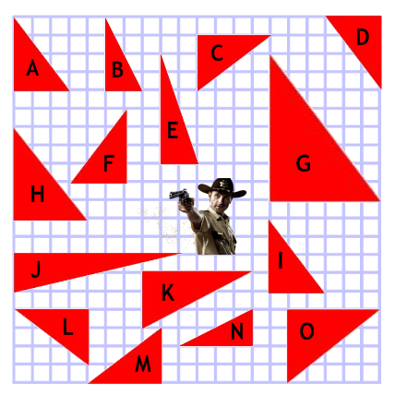
Situation 2:
Deputy Crimes has been informed that any buildings that are similar to Shape A are safe.
Which of the buildings below can he go in safely?
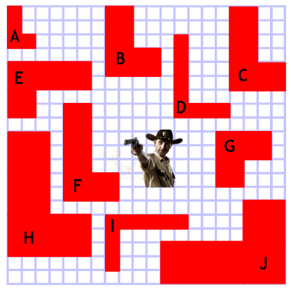
Situation 3:
Deputy Crimes has been informed that any buildings that are similar to a cuboid of dimensions 3cm by 4cm by 5cm are safe. Which of the buildings below can he go in safely?
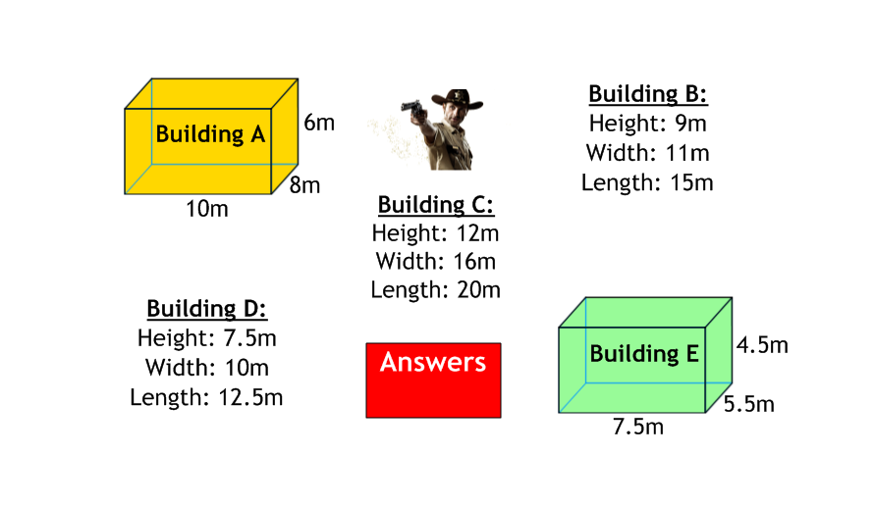
Situation 4:
Deputy Crimes knows that the picture of the triangle and the silhouette of the building are similar. He wants to know the missing lengths on both triangles and the scale factor of enlargement.
