The Walking Dead – Season 2 – Locus and Construction
Situation 1:
Deputy Crimes has to escape the shufflers and nibblers bay treading a very exact path past them. There are zombies at point A and point B and the path to walk down is equidistant from both those points. On the map below can you show the path Deputy Crimes must take?
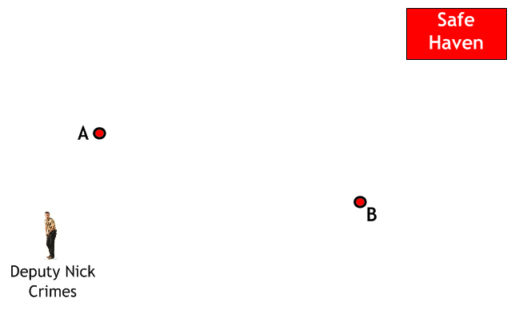
Situation 2:
Deputy Crimes has to escape the shufflers and nibblers bay treading a very exact path past them. There are zombies behind fence A and fence B and the path to walk down is equidistant from both fences. On the map below can you show the path Deputy Crimes must take?
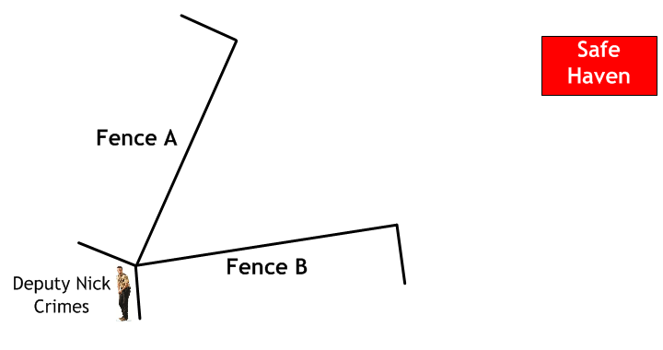
Situation 3:
Deputy Crimes has to escape the shufflers and nibblers bay treading a very exact path past them. There are zombies at points A, B and C and the path to walk down is equidistant from A and B to retrieve the medical supplies and then from B and C back to the safe haven. On the map below can you show the path Deputy Crimes must take?
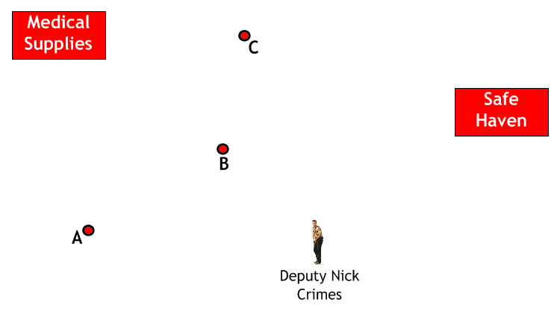
Situation 4:
Deputy Crimes has managed to chain a group of zombies to a fence. The zombies can reach out 2 metres from the fence. Show the area Deputy Crimes cannot walk without being caught by zombies.

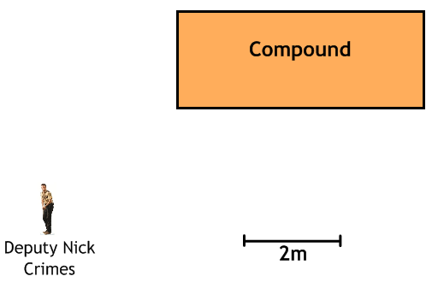
Situation 5:
Deputy Crimes has managed to chain a group of zombies to a fence. The zombies can reach out 3 metres from the fence. Show the area Deputy Crimes cannot walk without being caught by zombies.

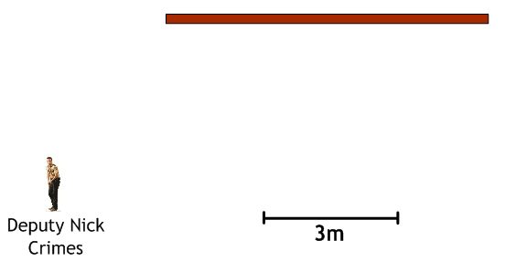
Situation 6:
Deputy Crimes is in a compound and has managed to trap two groups of zombies in two sheds. The zombies can reach out 2 metres from each shed. Show the area Deputy Crimes can walk without being reachable by zombies.
