The Walking Dead – Season 3 – Bearings
Journey 1:
It is safer to travel at night so Deputy Crimes needs very precise instructions and bearings in order to travel safely.
Describe each bearing and distance Crimes must travel.
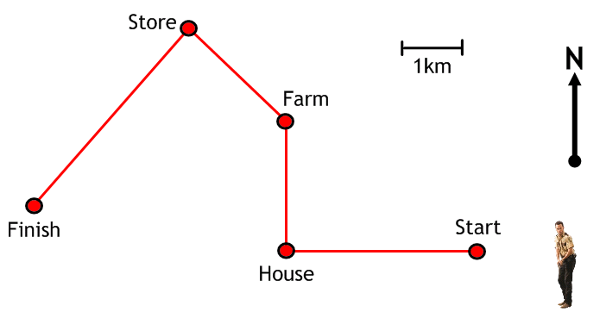
Journey 2:
It is safer to travel at night so Deputy Crimes needs very precise instructions and bearings in order to travel safely.
Describe each bearing and distance Crimes must travel.
