Thor and Loki - Answers
Thor and Loki are brothers, but Loki is continually battling to win the throne of Asgard from Thor. Loki has recruited numerous villains to fight for him, but they have to deal with Thor's trusted and extremely powerful hammer.

Battle 1 - Answer
Twenty of Loki's recruits have surrounded Thor. His hammer will defeat anyone within 14 metres of Thor. Who will escape?
Scale on your worksheet: 1 centimetre = 2 metres
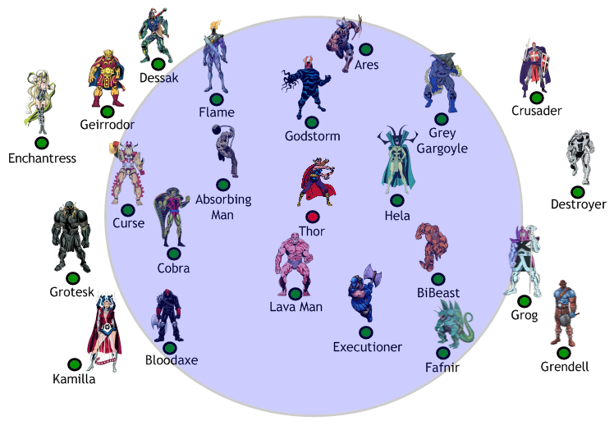
Battle 2 - Answer
Fifteen more of Loki's recruits have surrounded Thor in a royal outbuilding. His hammer will defeat anyone within 4 metres of the outbuilding. Who will escape?
Scale on your worksheet: 1 centimetre = 1 metre

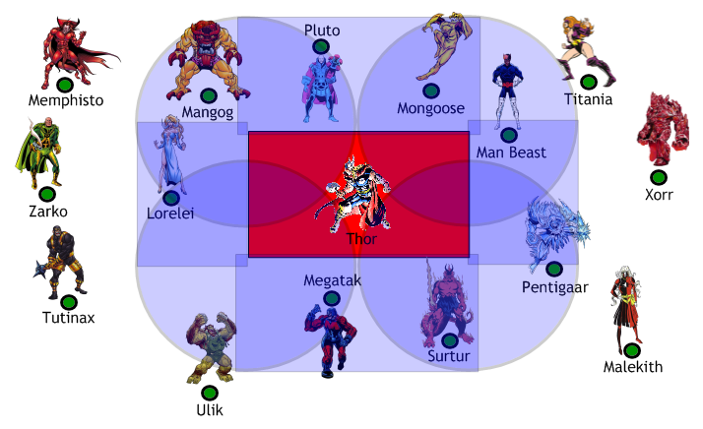
Battle 3 - Answer
Two groups of Loki's recruits are preparing to attack. In order to defeat them before they reach him Thor must throw his trusty hammer exactly down the middle of the two groups.
Accurately draw the exact line on which Thor must throw his hammer.
Scale on your worksheet: 1 centimetre = 1 metre
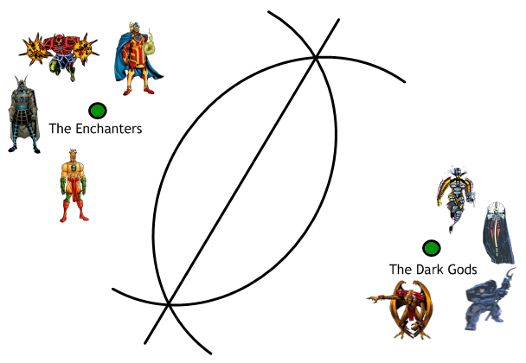
Battle 4 - Answer
Two groups of Loki's recruits are preparing to attack. They are lining up to fight Thor on two fronts. Thor must throw his hammer down the middle to defeat them all at the same time.
Accurately draw the line on which Thor must throw his hammer.
Scale on your worksheet: 1 centimetre = 1 metre
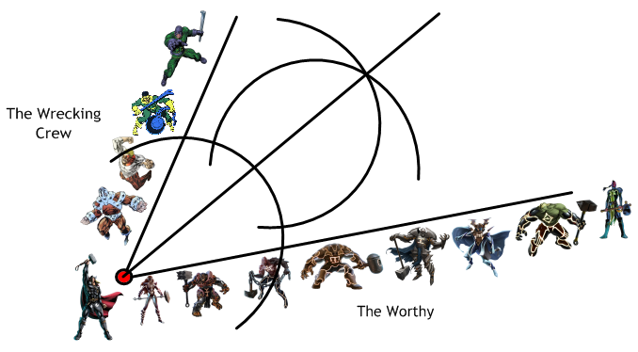

Battle 5 - The Final Showdown - Answer
Loki's recruits have trapped Thor in the throne room. To defeat all of Loki's troops Thor must find an area where he is:
Within 5 metres of the throne;
Closer to the East wall than the South wall;
Nearer to the Gold Pillar than the Silver Pillar.
Find the area in which Thor must position himself in order to defeat Loki's army.
Scale on your worksheet: 1 centimetre = 1 metre
