Learn Its
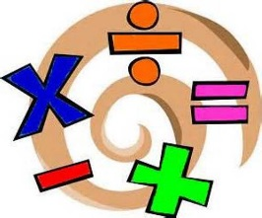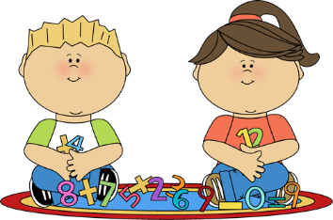
Year 1 Autumn term 1
The aim of these ‘Learn Its’ which are focused on in school and for Home Learning is to give the children regular but short practice at key maths facts. This will help them develop their confidence and recall, which will help them apply them in their maths learning.
Wherever we can we want to make this practice fun and practical. Lots of opportunities to talk about the maths and to show we as adults enjoy it too.

To write numbers 1 to 20 accurately with no reversals.
- Trace them in sand, paint the numbers, with their fingers trace over numbers they spot in the world around them
- Play spot the odd one out. Adult writes 3 numbers, one of which is reversed. The child has to spot and correct the wrong one. Then reverse the roles.

To find 1 more from any number within 10, mentally.
- When counting objects (e.g. socks, sweets, toys, pieces of Lego), ask them how many they would have if they had one more
- Sing songs (e.g. “1 2 3 4 5 Once I caught a fish alive” “One two buckle my shoe” “One potato, two potato, three potato”
- Discuss examples of scores in sport (e.g. how many goals will they have scored if they score one more?)

Bar Model

To find 1 less from any number within 10, mentally.
- At mealtimes, count the number of (e.g. chips, sausages…) and ask how many will be left when they have eaten one
- Sing songs (e.g. “There were 10 in the bed” “Five little speckled frogs” “Ten fat sausages sizzling in a pan”)
- Memory tray game. A selection of objects on a tray. The child counts them and tries to remember them all. They close their eyes and one object is taken away. They re-count the number of objects and try to remember the object that has been removed.

Estimate a number of objects to 10.
- Guess the number of particular items on a plate, people in a queue, cars in a road / car park, people at a park, toys left abandoned on a bedroom floor…
- Quick count tray game. Put a certain number of the same objects on a tray. The child has a set amount of time to quickly scan and try and estimate how many are there before the tray gets covered. Then count to check

Know and recall the addition and subtraction facts for all numbers to 5.
- Play a question and answer paired game. Adult says a number and the child says the pair that makes it 5 (e.g. 3 + 2 = 5)
- With 5 objects find all the ways of putting them into two piles / on two plates. Each time say the sentence together (e.g. 4 + 1 = 5 and 5 – 4 = 1)
- Play a card game with only the numbers: 1 2 and 3. Take it turns taking a card to try and get to 5 (but not going higher). (Essentially Pontoon or 21 but with smaller numbers)

