Learn Its
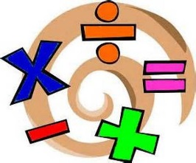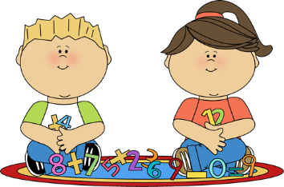
Year 1 Autumn term 2
The aim of these ‘Learn Its’ which are focused on in school and for Home Learning is to give the children regular but short practice at key maths facts. This will help them develop their confidence and recall, which will help them apply them in their maths learning.
Wherever we can we want to make this practice fun and practical. Lots of opportunities to talk about the maths and to show we as adults enjoy it too.

To begin to practically explore halving, sharing and doubling through play and in real life contexts.
- Discuss and show halving and doubling with food, e.g. cutting toast in half, doubling the number of sandwiches / crisps…
- Pairing socks / shoes to double numbers
- Sharing counters or cards in games

To begin to relate symbols (+ - =) to mathematical contexts.
- When counting in practical contexts at home discuss how what you are doing might be written as a number sentence (e.g. we’ve had 20 minutes playing this game and we have 10 more minutes left. The journey in the car was going to take 20 minutes, we have been driving for 5 minutes so how long do we have left? (And no we are not there yet!)

To recognise and use ‘first, second, third etc’ to describe the position of numbers within a set.
- Looking at scores when playing online or real life games
- Looking at positions in tables of favourite sports teams
- Looking at the numbers of different objects in a room (e.g. books, toys and chairs or forks, spoons and knives in a drawer or on the table)

To be able to ‘find the difference’ between two amounts in practical contexts, using the language of more and less, understand the meaning of plus, more than, fewer than.
- Discussing amount of money needed in coins for buying a small item (under £1 in a shop)
- Comparing the amount of cards, counters or points when playing a game
- Comparing the number of socks or cutlery or straws or sweets…

Mentally add and subtract 1 to any number to 10 and record the operation, beginning to use the symbols (= + -).
- Play a “What’s one more” or “What’s one less” game with cards. Simply place one card face up and ask your child to give the answer verbally. (Begin to record a few number sentences)
- Count steps when going up and down stairs
- Count chips or sandwiches… during a meal. How many will you have when you have eaten one more?
- Play online games, including using Purple Mash

Bar Model
5

