Learn Its
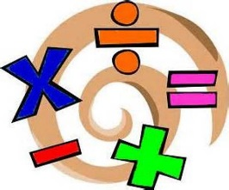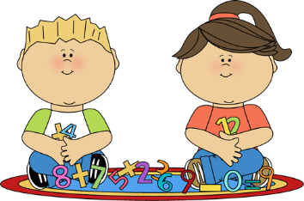
Year 1 Spring term 1
The aim of these ‘Learn Its’ which are focused on in school and for Home Learning is to give the children regular but short practice at key maths facts. Some of the facts may seem quite basic, but this practice will help them develop their confidence and recall, which will help them apply them in their maths learning.
Wherever we can we want to make this practice fun and practical. Please feel free to make up your own games / activities, or adapt / swap the ones suggested below. We also need lots of opportunities to talk about the maths and to show that we as adults enjoy it too.

To know and quickly recall all pairs of numbers with a total of 10 (number bonds).
- Play a game with numbered cards. Put down two cards and add them together, or put down one card and say aloud how much needs to be added to make 10
- Play games involving dice rolls. This might include games which involve moving spaces around a board with counters
- Practice counting groups of objects (toys, sweets, cutlery, socks…) and work out how many more would be needed to get to 10
- Play some online maths games: this might include Purple Mash or BBC KS1 Bitesize

To know all addition and subtraction facts for all numbers to 10.
- Play games as above but for other totals than 10
- Memory tray game. Start with a certain number of objects on a tray. Your child closes their eyes, a certain number of objects are secretly taken away, and when they reopen their eyes they have to work out how many were taken away by counting how many are left on the tray

To use the symbols ( + - = ) to record the answer to a mental calculation.
- On paper, card, with pencils, pens, paint… record the number sentences created in the previous games. Could they consider how they might put the number sentences in order?
- Give your child a number sentence with a missing number (which may be the answer or another missing number, e.g. 3 + 4 = or 8 - __ = 6). They could try to make the number sentences using objects you have at home and then record the missing number

To add 2 or 3 sets of numbers together to make 10.
- “Roll 10”. Roll a dice, agree what the number is and then work out what will be needed to be rolled next to make 10. If the second roll doesn’t take you to 10, what would have to be rolled the third time. (If you go beyond 10, then like Pontoon (21) you are bust)
- “Fingers down”. Put out your two hands with some fingers tucked underneath. Your child with their eyes closed, has to feel how many fingers you have stretched out, and then has to work out how many fingers are tucked away. (This could also be played with a pair of gloves)
- Have a set of 10 objects. Take it in turns finding different ways of placing them into 3 piles, but discuss how they will always still equal 10. (This could also be done with the numbers 5 to 9)

To know all doubles of numbers to 5.
- Roll a dice. Agree the number. Roll another dice until you get the same number. Count the number of dots.
- Pairs of socks. When sorting socks, put out a certain number of pairs and predict how many socks in total there are in those pairs. (e.g. 4 pairs = 8 socks)
- Play dominoes. Each time you add a domino to the line, predict and then count how many dots there are in the matching pair.

To understand the value of digits in teen numbers.
- When you see teen numbers in real life ask your child what the 1 and the unit number stands for. How many tens? How many units?
- Write, draw, paint, trace in sand… a teen number. Ask your child to say and draw the amount of tens and units. (In school we use Diennes to show this practically. A ten is a stick and units are small cubes. We ask children to draw these with a ten being a straight line and units being smaller dots)
- “Trace on my back”. With a finger trace a teen number on your child’s back. Can they work out from the feel what the number is? Can they say how many tens and units there are in the number?

To begin to know some multiples of 10 and begin to count forwards in multiples of 10.
- Hands on the table. When having a meal, or playing a game as a family, everyone puts their hands on the table. How many sets of 10 are there? How could we count them? (Discuss that counting them up in 10s is quicker than counting in 1s)
- Look at the multiples of 10. What can you spot? How are they similar? (All end in zero)
- “Tens tennis”. Playing in pairs or in a group. One person says 10, the next 20, the next 30… Can you keep the rally going up to 100? (This can be a good game to play while waiting in a queue or during a car journey, though it probably won’t last the whole journey!)

Bar Model
5

