Learn Its
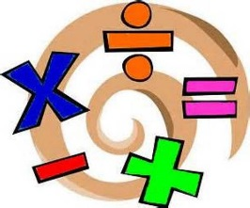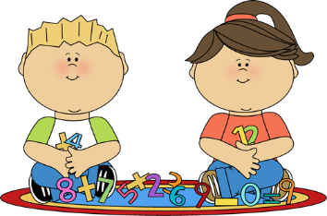
Year 2 Autumn term 1
The aim of these ‘Learn Its’, which are focused on in school and for Home Learning is to give the children regular but short practice at key maths facts and skills. This will help them develop their confidence and recall, which will in turn help the children to apply them in their maths learning.
Wherever we can we want to make this practice fun and practical, but with increasing opportunities to record their thinking using visual models and number sentences. There should continue to be lots of opportunities to talk about the maths and to show we as adults enjoy it too.

To count forwards and backwards from any number in 1’s, within 100.
- Counting forwards and backwards in games involving dice rolls (e.g. Snakes and Ladders)
- Counting cars that drive past during a journey, points scored in a quiz or a sport that is being watched.

To partition 2 digit numbers within 100 into 10’s and 1’s in different ways and know the value of each digit.
- Given a verbal 2 digit number (e.g. 45) the child can explain that this could be partitioned into 40 and 5. (It could also be partitioned into 30 and 15 or 20 and 25)
- Given a written 2 digit number the child can draw an arrow from each digit and right what the number is (e.g. 27 is 20 and 7).

Bar Model
5

To write and order numerals to 100, using 0 as a place holder accurately.
- Given any 2 or 3 numbers verbally, children can say them back in order either starting with the lowest or with the largest. Explaining why they have put them in this order.
- Given more than 3 numbers written down, children can write them in order. Again explaining why they have put them in this order

To find 1 and 10 more / 1 and 10 less from any number, mentally, within numbers to 100.
- “Speed response”. Given a number verbally and an instruction to find 1 or 10 more or less, the child answers as quickly as possible. How many can they answer in 1 minute?
- Given 1 number work out 1 and 10 more and less. What is pattern they can spot? Can a 100 square help?

To add and subtract mentally a 1 digit number or a multiple of 10 to / from a 2 digit number (e.g. 23 + 30 = or 34 – 20 = ).
- When considering sports scores ask what the score would have been if they had scored 10, 20 or 30 more or less.
- Given a 2 digit number ask how many you would need to add or takeaway to get to the next multiple of ten (e.g. 67 – 7 = 70 or 67 +3 = 70)
- When reading a book, record the number of the page read up to and discuss what page will be reached after another 10, or 20 pages. How many pages were read today?

To count forwards and backwards accurately in steps of 2, 5 and 10 and start to relate to multiplication and division, solve simple X and ÷ problems pictorially.
- Chant the multiples of 2, 5 or 10 as you climb a set of stairs.
- Explore real life problems (e.g. we have 4 people coming for tea and we need to cook 3 sausages for them each? How many sausages in total? We have a bag of 20 sweets to share between 5 people, how many will they each get? Use an array to draw it.
- Play on the “Times Tables Rockstars” online game.

To add and subtract mentally 2 digit numbers that do not involve bridging through the 10’s boundary. (e.g. 23 + 45 or 87 – 24 = )
- Look for pairs of 2 digit numbers on car registrations.
- How much would two sweets or chocolate bars cost in total? (e.g. 40 + 35 = )
- Which house numbers in your street can you add or subtract?

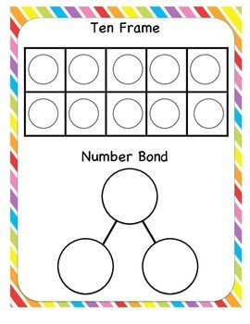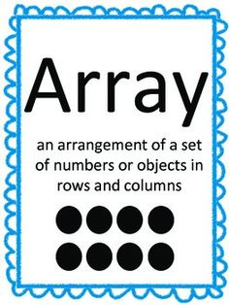

100 Square
