Learn Its
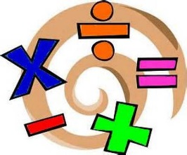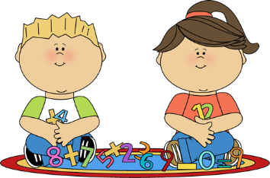
Year 2 Autumn term 2
The aim of these ‘Learn Its’, which are focused on in school and for Home Learning is to give the children regular but short practice at key maths facts and skills. This will help them develop their confidence and recall, which will in turn help the children to apply them in their maths learning.
Wherever we can we want to make this practice fun and practical, but with increasing opportunities to record their thinking using visual models and number sentences. There should continue to be lots of opportunities to talk about the maths and to show we as adults enjoy it too.

To bridge through 10 mentally, using known number facts when adding and subtracting.
- Play Pontoon (21) and practice adding numbers which go from single digit into 10-20 digits
- Create a random 2 digit and 1 digit number with two cards (e.g. 15 and 7). What’s the biggest and smallest number we can make by adding the two numbers or taking the smaller away from the larger?
- Counting and adding or subtracting objects in a room at home
- Adding or subtracting fingers when two people put fingers out on the table (with some hidden underneath) (e.g. adult has 8 fingers out child has 5 = how many in total or 2 adults have 16 fingers out in total and child has 9 = what’s the difference)

To use near doubles as a mental calculating strategy.
- Given a single digit number the child verbally says the double
- When pairing socks or shoes (there’s nearly always one missing). How many would we expect there to be in there are (e.g. 4 pairs)? We have one missing, or when extra that has appeared from somewhere, so how many are there actually?

To know doubles of all numbers to 20 and their corresponding halves.
- Practice them verbally
- Pairing cards in a game
- Pairing socks and shoes in practical contexts
- Sharing a certain number of cards, toys, sweets… between two people in a practical context

To count in odd and even numbers to 100.
- Using a numberline count up and down verbally
- Playing a skipping, hopscotch type game which involves counting every other number
- Counting out cards, sweets… between two people. (2, 4, 6…)
- Counting out socks, shoes, gloves… in pairs (2, 4, 6…), but sometimes starting with a spare ‘rogue’ one (1, 3, 5…)

To solve missing box problems.
- Examples of Missing box problems are: 5 + __ = 9 or __ - 7 = 3
- Examples of questions in practical contexts:
- There should be 12 toys in this box but there are only 4. How many are missing? (12 - __ = 4)
- We will be driving for 20 minutes. We have been driving for 15 minutes so far. How much longer do we have to drive? (15 + __ = 20)

Being able to work out what must be added to any 2 digit number within 100, to make the next multiple of 10.
- Playing verbal number bonds tennis. When an adult ‘serves’ a number across the net, your child has to return with the number that will take it to ten and the total. (e.g. “7” and then “+3 =10). Continue to “verbal rally” with other 2 digit numbers ending in 7 (e.g. “27” and then “+3 = 30)
- Build a Lego or Minecraft wall with pairs of blocks that equal 10 circles (the bobbles on top). Each row of the wall should then go up in tens (e.g. 10, 20, 30…) Discuss what is being added each time.
- When playing a game like snake and ladders, working out how many needed to get your piece to the next multiple of 10 (e.g. 30, 50 or 90)

To begin to relate repeated addition and repeated subtraction to x and ÷ relating an array to multiplication and solve simple multiplication and division problems.
- When counting objects repeatedly with the same amount (e.g. socks in 2s: 2, 4, 6… or quarters of toast/sandwiches in 4s, 4, 8, 12…) write the numbers out on a blank numberline or in a list on a piece of paper.
- Consider how these numbers could be drawn in rows of dots (e.g. 3 rows of 2 dots or 5 rows of 4 dots…) (See an example of an array below)
- Make arrays practically when sorting out/tidying objects at home: e.g. toys, books, counters, jigsaw pieces, sweets…

To find ½, ¼ and ¾ of shapes and sets of objects.
- Cut paper or card for pictures or model making into halves and quarters (making sure the pieces are equal, e.g. the same size)
- Cutting sandwiches, toast, pizza… into halves and quarters. Discuss what you would have if you had 2 quarters, what else could we call it? What would happen if you had 3 quarters? How much would you need to add to make a whole?...

Bar Model
5

