Learn Its
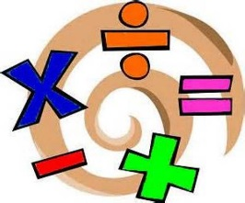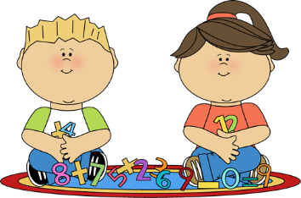
Year 2 Spring term
The aim of these ‘Learn Its’ which are focused on in school and for Home Learning is to give the children regular but short practice at key maths facts. Some of the facts may seem quite basic, but this practice will help them develop their confidence and recall, which will help them apply them in their maths learning.
Wherever we can we want to make this practice fun and practical. Please feel free to make up your own games / activities, or adapt / swap the ones suggested below. We also need lots of opportunities to talk about the maths and to show that we as adults enjoy it too.

To count beyond 100 accurately and write 3 digit numbers with correct place value.
- Starting from a number between 50-100 count up to and beyond 100
- Roll a dice 3 times, or pick 3 playing cards at random. Create the lowest and highest 3 digit number possible. Write the numbers out and explain the value of each digit (e.g. 462 = 4 hundreds, 6 tens and 2 units).
- An adult opens a page in a large book and read the page number (3 digits). Your child write the number and the value of each number (e.g. 137 = 100 + 30 + 7)

To count in multiples of 100 to 1000 and backwards.
- “Multiple tennis”. As a pair say the multiples of 100 or 1000 in turn. This can be done whilst playing catch with a ball or balloon or kicking a ball between each other at the same time.
- “Missing multiple”. An adult says a sequence of multiples of 100 or 1000 but missing one number out. Can your child listen out for and identify the missing number?
- Paint or type the multiples of 100 or 1000 to create a poster

To know pairs of 2 digit numbers with a total of 100 (e.g. 32+68).
- Roll a dice twice or pick two playing cards at random. Which 2 2-digit numbers can be made. Which numbers need to be added to make 100?
- Use a 100 square (like the one at the end). Pick a number. How many tens and ones need to be added to get to 100. (It helps the children to understand that moving down a square adds 10 and moving a square to the right adds 1)
- “Century challenge”. In pairs. One person says a 2-digit number aloud, the other has an agreed number of seconds to work out the paired number that will total 100. Who can get 5 right first? How quickly can your child do it?

Multiplication and division facts for the 2, 5 and 10 times tables.
- Listen to and sing along to online songs
- Write out the multiples of 2, 5 and 10 as repeated addition on numberlines
- Practice chanting the tables together
- “I know…so…” Given a fact (e.g. 2 x 4 = 8) what 3 other facts can be made with the same numbers? ( 4 x 2 = 8 8 ÷ 4 = 2 8 ÷ 2 = 4)
- Given a multiplication or division number sentence, can your child draw an array (see below) to prove it (e.g. 15 ÷ 5 = 3)

To know doubles and halves of all numbers to 20.
- Take it in turns picking a number at random (1-20). Can you double and halve this number?
- Discuss and count when sharing practically (e.g. food items…) and when doubling (e.g. sorting shoes, socks, gloves…)

To know all subtraction and addition facts for each number up to 20.
- “Target number”. Select a number between 1-20 at random. How many different ways can you find and record of making that number using pairs of numbers between 1-20 to add and subtract. This could be played as a game in a pair or group, who will be the first person who cannot think of another pair to create the Target Number?
- “Speed Recall”. How quickly can your child answer 5 or 10 mixed addition and subtraction questions (with answers between 0-20)? Speed is not essential, particularly when starting the challenge, but most children are motivated more if they can see they are becoming quicker over time)

Understand division as sharing and grouping and recognise that it is the inverse of multiplication.
- 12 ÷ 4 = 3. Division as sharing. Start with 12 counters / objects. Share them between 4 people, plates or cuddly toys. There should be 3 in each pile.
- This can also be done through drawing. Draw 12 dots and 4 circles. Draw a line from each dot to share them between the 4 circles.
- 12 ÷ 4 = 3. Division as grouping. Start with 12 counters / objects. Put the counters / objects into groups of 4. There should be 3 groups.
- This can also be done through drawing. Draw 12 dots. Draw a bubble around 4 of the dots. Repeat two times. This can also be done on a numberline, with 3 jumps of 4 to get to 12.
- Draw an array of 3 rows of 4 dots, so with 12 dots in total. Draw bubbles around the dots in each vertical column (this is similar to sharing between 4 people). Now draw bubbles around each horizontal row (this is similar to 3 groups of 4.

Bar Model
5

