Learn Its
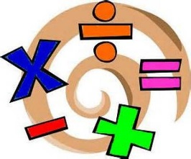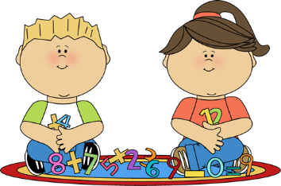
Year 4 Autumn term
The aim of these ‘Learn Its’, which are focused on in school and for Home Learning is to give the children regular but short practice at key maths facts and skills. This will help them develop their confidence and recall, which will in turn help the children to apply them in their maths learning.
Wherever we can we want to make this practice fun and practical, but with increasing opportunities to record their thinking using visual models and written methods. There should continue to be lots of opportunities to talk about the maths and to show we as adults enjoy it too.

Order and compare numbers beyond 1000.
- Find the years that family members were born and put them in order.
- Roll a dice 4 times. Create the smallest and largest possible 4 digit numbers. Make 4 more numbers and put them all in order. Use the < and > signs.
- Look at costs of different items that might be bought for less than £100. Use the pounds and pence amounts to create 4 digit numbers, and put them in order.

Round any number to the nearest 10, 100 or 1000.
- Take the years that family members were born and round to the nearest 10 and 100.
- Find distances in kms between major world cities and round them to nearest 10, 100 and 1000 kms.
- Research the weight of a range of animals in grams. Rank the animals in order from lightest to heaviest or vica-versa.

Find 1000 more or less than a given number.
- Use some of the 4 digit numbers from the previous ‘Learn Its’ and find 1000 more or less.
- Roll a dice 4 times to create a 4 digit number. Find 1000, 2000 and 3000 more and less than the number. Explain how they know how to do this.

Recognise the place value of each digit in a four-digit number.
- Use some of the 4 digit numbers from the previous ‘Learn Its’ and record the value of each digit. (e.g. 4731 = 4000 + 700 + 30 + 1 = 4 thousands + seven hundreds + 3 tens + 1 unit)

Add and subtract numbers with up to 4 digits.
- Use numbers some of the numbers from the previous ‘Learn Its’. Add and subtract them using the formal column method, but also show an alternative method to prove it

Recall multiplication and division facts for multiplication tables up to 12×12.
- Practise chanting them going up and down stairs
- Play ‘Times Table Tennis’ in pairs: taking in turns to say a multiple back and forwards
- Draw an Array for x6 x7 x9 x11 and x12 times tables, labelling each row with the accumulated total.

Count up and down in hundredths.
- Start from any number and count verbally up or down (e.g. 16 hundredths, 17 hundredths, 18 hundredths…)
- “Hundredth Circle” in a group going round a circle. Again start from any number of hundredths. Go upwards until one person says a hundredth and claps at the same time. This changes the direction going around the circle and the group have to start counting downwards instead.

Measure and calculate the perimeter of squares and rectangles.
- Look for objects that are square or rectangular shaped in your house. Using a ruler measure the length and width of the shapes and then calculate the perimeter and area.
- Design a new room layout. Measure the length and width of a room. Calculate the perimeter and area. What furniture could you put in this room? (Could you design an ‘ideal bedroom’?) What size furniture would you need and how might it all fit in. (If you are really interested, you could try and make flat cardboard shapes to scale and place them on outline plan on the room)
- Build different buildings from Lego or in Minecraft. Measure the length and width and calculate the perimeter and area.

Identify lines of symmetry in 2-D shapes presented in different orientations.
- “Mirror Hunt”. Check objects in your house / classroom with a mirror. Which objects look the same if you hold a mirror along a half way line? Which don’t? What if you rotate the mirror to hold it in different positions? Can you explain why certain objects fit in each group (symmetrical and non-symmeytrical)

Describe positions on a 2-D grid as coordinates.
- Play “Battleships”. This can either be with the letters and numbers in the squares or on the line.
- Important to remember that the x axis (horizontal) value is written first, then the y axis (vertical). Practice saying “along the corridor and up the stairs” as you walk towards the stairs at home. (This can also be developed with “along the corridor and down the stairs”, as the children will learn about negative numbers in the 4 quadrants of grids in the future.

Bar Model

