Learn Its
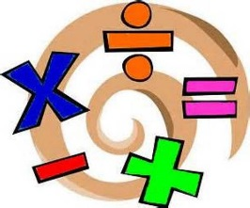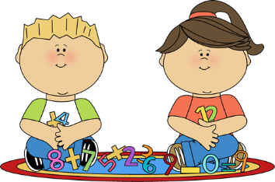
Year R Spring 1 term
The aim of these ‘Learn Its’ which are focused on in school and for Home Learning is to give the children regular but short practice at key maths facts. Some of the facts may seem quite basic, but this practice will help them develop their confidence and recall, which will help them apply them in their maths learning.
Wherever we can we want to make this practice fun and practical. Please feel free to make up your own games / activities, or adapt / swap the ones suggested below. We also need lots of opportunities to talk about the maths and to show that we as adults enjoy it too.

To write numerals 1 to 5 accurately with no reversals.
- Practice tracing them, writing them with pencils or colours, painting them, making them out of playdough or twigs…
- Spot the numerals when out and about (e.g. house numbers, numbers in shops, page numbers in books…)

To say the number that is 1 more, or 1 less than any number up to 10.
- Have a selection of objects on a plate or tray. Count the number of objects. How many would there be if we added one more? How many would there be if we took one away?
- Roll a dice. Say the number aloud. Say the number that is one more or less

To know number pairs up to 5.
- Have the numbers 0-5 on card or pieces of paper. Which pairs could we use to make 5? What about pairs that make 4 or 3?
- Have 5 objects (e.g. toys, counters, socks…). In what different ways could we split them into two groups: how many are in each group?

Understand addition as combining of 2 or more groups to make something bigger.
- Use 2 groups of objects (e.g. counters, toys…). Count how many are in each group. Put the groups together. How many have we got now? Are there more or less objects?
- Roll two dice or pick two number cards at random (numbers 1-10). Start with the largest number and count on the amount of the second number (this can be done with objects). What is the new number? Is it bigger or smaller?
- Discuss the numbers involved when adding any two groups in everyday practical situations
- Practice using the words: add, plus and total when discussing addition

Understand subtraction as taking away from a group to make something smaller.
- Have a group of objects (e.g. counters, toys…) and count how many there are. Roll a dice or pick a number card at random. Can you take that number of objects away from the group? What number of objects are now in the group? Is that a bigger number or smaller number? (Can you repeat it without getting down to zero?)
- Roll two dice or pick two number cards at random (numbers 1-10). Start with the largest number and count back the amount of the second number (this can be done with objects). What is the new number? Is it bigger or smaller?
- Discuss the numbers involved when subtracting in everyday practical situations (e.g. food left on a plate, minutes until bedtime…)
- Practice using the words: take away and minus when discussing subtraction

